**E – Learning Visualized and Audio Learning Web for Phonetic Reading**

**A Presented to the**

**Faculty of the College of Computer Science**

**Technological University of the Philippines**

**Ayala Blvd., Manila**

**By**

**BAUTISTA, JOHN KENNETH O.**

**DORADO, DENMARK B.**

**MARQUEZ, JAZPER C.**

**RAMIREZ, KAIROS P.**

**In Partial Fulfillment of the Requirements for the Degree**

**Bachelor of Science in Information Technology**

**JUNE 2023**

**APPROVAL SHEET**

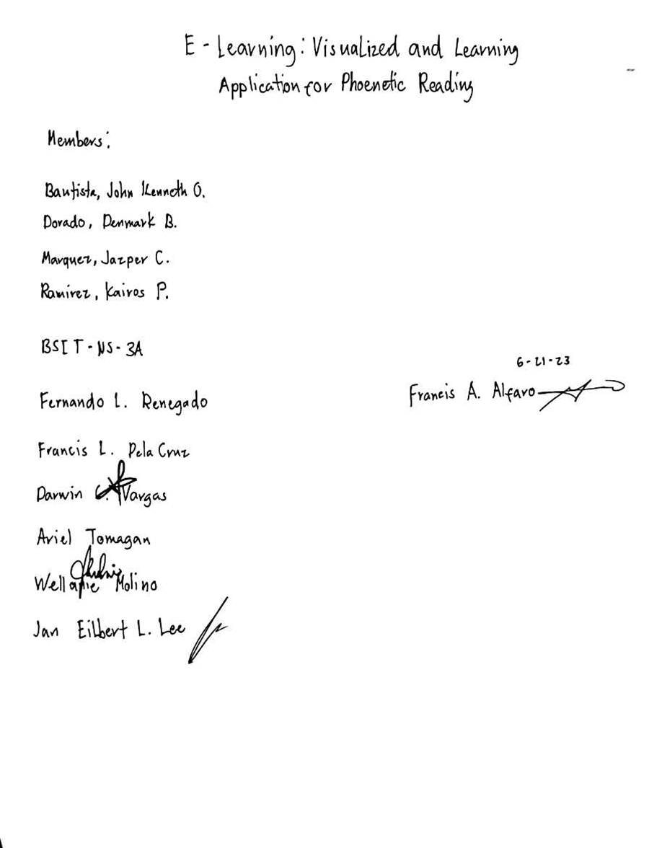

**ACKNOWLEDGEMENT**

We, the researchers, wish to convey our profound gratitude to all those who made significant contributions to our research:

Our heartfelt thanks go to our thesis adviser, Dr. Wellanie Molino, whose invaluable insights and expertise greatly enhanced our work. Her generous investment of time, knowledge, and effort provided the support and motivation needed to complete our thesis.

We also extend our sincere appreciation to our thesis professor, Prof. Francis A. Alfaro, for his unwavering guidance and support throughout this project.

Our deepest gratitude goes to our families, whose financial and emotional support was crucial. Their encouragement helped us persevere and remain resilient during challenging times.

Finally, we are immensely grateful to Almighty God for granting us understanding, patience, and guidance throughout this journey.

- The Researchers

**ABSTRACT**

This study developed a web-based E-learning system that aims to provide a friendly electronic learning web application that is accessible to anyone, especially young kids who are in nursery level who want to learn and improve their reading and pronunciation skills. The web application developed in Visual Code Studio together with NodeJs, ReactJs and Tailwind as the CSS framework. The developed web application passed the evaluation and testing by conducting and functionality testing and security testing. The E-learning system is evaluated by 50 teachers and parents who also guide the users for their learnings and based on the conducted evaluation the E-learning system passed and gained “Highly Acceptable” with the score mean of “3.76”.

|  |  |
| --- | --- |
| **TABLE OF CONTENTS** |  |
| TITLE PAGE | 1 |
| APPROVAL SHEET | 2 |
| ACKNOWLEDGEMENT | 3 |
| ABSTRACT | 4 |
| TABLE OF CONTENTS | 5 |
| LIST OF FIGURES | 7 |
| LIST OF TABLES | 8 |
| LIST OF APPENDICES | 9 |
| **Chapter 1 – THE PROBLEM AND ITS SETTING** |  |
| 1.1 Introduction | 10 |
| 1.2 Background of the Study | 11 |
| 1.3 Objective of the study | 14 |
| 1.3 Scope and Delimitations | 14 |
| 1.4 Significance of the Study | 15 |
| **Chapter 2 – CONCEPTUAL FRAMEWORK** |  |
| 2.1 Review of Related Literature and Studies | 17 |
| 2.2 Conceptual Model of the Study | 51 |
| 2.3 Operational definition of Terms | 53 |
| **Chapter 3 – RESEARCH METHODOLOGY** |  |
| 3.1 Project Design | 54 |
| 3.1.1 Hierarchical Input Output Process | 54 |
| 3.1.2 System Flowchart | 55 |
| 3.1.3 Use Case Diagram | 56 |
| 3.1.4 Database Design | 57 |
| 3.2 Project Development | 58 |
| 3.3 Operation and Testing Procedure | 60 |
| 3.4 Evaluation Procedure | 63 |
| **Chapter 4 – RESULTS AND DISCUSSION** |  |
| 4.1 Project Description | 65 |
| 4.2 Project Structure | 65 |
| 4.3 Project Capabilities and Limitations | 72 |
| 4.4 Project Evaluation | 74 |
| 4.5 Functional Suitability Test Results | 74 |
| 4.6 Security Test Result | 77 |
| 4.7Evaluation Results | 78 |
| **Chapter 5 – SUMMARY OF FINDINGS, CONCLUSIONS, AND RECOMMENDATIONS** |  |
| 5.1 Summary of Findings | 85 |
| 5.2 Conclusion | 87 |
| 5.3 Recommendations | 88 |
| **REFERENCES** |  |
|  |  |

**LIST OF FIGURES**

|  |  |
| --- | --- |
| Conceptual Model of the Study | 51 |
| Hierarchical Input Output Process | 54 |
| System Flowchart | 55 |
| Use Case Diagram | 56 |
| Database Design | 57 |
| Project Development | 58 |
| Home Page | 66 |
| Login Form | 66 |
| Registration Form | 67 |
| VerificationPage | 67 |
| LetterPage | 68 |
| User Profile | 68 |
| Practice Page | 69 |
| Reading Material Page | 69 |
| Pop The Balloon | 70 |
| Say The Word | 70 |
| Pick The Word | 71 |
| Guess The Word | 71 |

**LIST OF TABLES**

|  |  |
| --- | --- |
| Testing Procedures | 60 |
| Rating Scale for the Evaluation Instrument | 64 |
| Scale Range and the Qualitative Interpretation | 64 |
| Testing Procedure for Functional Suitability in terms of students and admin | 75 |
| Testing Procedure for Security | 77 |
| User Experience Evaluation Result | 78 |
| Content Evaluation Result | 80 |
| Technical Aspects Evaluation Results | 82 |
| Overall Satisfaction Evaluation Results | 83 |
|  |  |

**LIST OF APPENDICES**

|  |  |
| --- | --- |
| Evaluation Instrument | 94 |
| Sampled Answered Evaluation sheet | 95 |
| Summary of Respondent’s Evaluation | 99 |
| Test Case for functional suitability | 100 |
| Test Case for security | 103 |
| Researcher’s Profiles | 74 |
|  |  |
|  |  |
|  |  |
|  |  |

**Chapter 1**

**THE PROBLEM AND ITS SETTING**

# Introduction

In the wake of the COVID-19 pandemic, the global education landscape underwent unprecedented transformations, leading to various challenges for students, parents, and teachers. The pandemic's disruption to traditional learning environments prompted parents to take on more active roles in their children's education, especially concerning fundamental skills such as reading. As AnnMarie Sossong, a renowned reading specialist, emphasizes, the readiness to learn to read varies significantly among children. While some youngsters show the potential to start reading as early as 3 years old, others may require more time to develop this essential skill. However, the age at which a child begins reading, even if it is around 6 to 7 years old, does not necessarily guarantee sustained academic advancement as they progress through school. Over time, individual abilities tend to level out, particularly in the context of evolving educational settings like the current hybrid learning models adopted by many schools.

The Philippines, like many countries, has faced considerable challenges in maintaining educational continuity due to the pandemic-induced disruptions. Recent educational assessments in the Philippines, published in the Philippine Daily Inquirer on April 1, 2022, highlight a worrisome issue: a considerable number of Grade 5 Filipino students exhibit inadequate proficiency levels in reading, writing, and mathematics. A comparative study undertaken by the United Nations Children's Fund (UNICEF) across countries including the Philippines, Vietnam, Laos, Myanmar, and Malaysia revealed that

This learning gap could have enduring consequences. Students struggling in these foundational skills during their primary education are likely to encounter difficulties as they transition to secondary school.

As a response to the shifting educational landscape, technology has emerged as a vital tool in delivering adaptable and engaging learning experiences. Within this context, the concept of "E-Learning: Visualized and Audiolized Learning Application for Phonetic Reading" emerges as a promising solution to address the issues exacerbated by the pandemic. This innovative approach, integrating personalized, multisensory, and technology-driven strategies, holds the potential to ameliorate the learning disparities outlined in recent educational assessments, both locally and globally. This research chapter delves into the intricate dimensions of this approach, exploring its capacity to bridge learning gaps, foster early intervention, and cultivate resilient reading skills among students, ultimately paving the way for a more inclusive and effective educational landscape.

# Background of the Study

Reading is an active process of constructing word associations. Reading with an objective helps the reader to organize their information and concentrate their attention. While the thought processes used to read can vary, the primary goal of reading is to understand the material. Reading may be a strategy of thought, and for young children, it is often a remarkable technique to help them develop their language abilities. It introduces them to new words and speech patterns. It also provides them with comprehensive information about the world, making it easier to learn about new topics in school.

The use of reading as a form of learning can have a significant impact on a child's vocabulary and understanding of the world, as well as their ability to think logically and solve problems, according to Caroline St. George (EdD), Associate Professor and Literacy Expert, Warner School, University of Rochester. St. George emphasizes that developing a love for reading early on in life is the key to unlocking lifelong learning opportunities.

The development of e-learning in the digital age has transformed the way we gain knowledge and skills. E-learning, also known as electronic learning, makes use of digital technologies and internet platforms to offer educational content and promote remote study. Its relevance stems from its potential to overcome geographical, economic, and personal obstacles to provide learners globally with accessible, flexible, and individualized education. This study investigates the various aspects of e-learning and analyzes its significant impact on education and training. E-learning has made education available to people who would otherwise be unable to attend traditional educational institutions. Furthermore, e-learning provides unrivaled flexibility. Learners can access courses and materials whenever they want. E-learning self-paced nature allows learners to personalize their learning experience to their unique needs, increasing engagement and knowledge retention.

One of the most major advantages of e-learning is its capacity to create tailored learning experiences. E-learning platforms evaluate learner data and give tailored material, evaluations, and suggestions by utilizing artificial intelligence and machine learning algorithms.

Gamification components are frequently used in e-learning platforms to increase engagement and motivation. Badges, points, leaderboards, and interactive quizzes make

learning a pleasant and immersive process. Gamification creates healthy competition, encourages active involvement, and rewards accomplishments, all which feed learners' motivation for knowledge acquisition and skill development. This aspect is the one of the aims of this study, to make learning enjoyable to the users or learners.

Learning letter-sound correlations is very important for young people because English uses letters within the set of letters to talk to sounds. Phonetic reading provides this information to help kids learn to read. Kids learn the sounds each letter makes. They also learn how changing the order of letters changes a word's meaning. Phonics as an educational approach is one of the best ways to learn to read because it reduces the English dialect to a fair forty-four. Instead of memorizing 1000’s of words on their own, children ‘decode’ words by breaking it down into sounds.

This study aims to create a web-based application that combines the three aspects that are mentioned. Reading learning software can be useful for a variety of reasons. To begin, reading learning apps can help users improve their reading skills by providing a methodical and engaging way to practice reading. This software can help users improve their vocabulary, reading speed, and comprehension. This reading learning application can help students study more effectively by providing dynamic and engaging content that is personalized to the user's learning level and preferences. This can help pupils stay motivated and engaged in the learning process. People with various learning disabilities can use it to access reading information in a way that is tailored to their specific needs. Reading learning programs are available at any time and from any location, giving them an easy way to practice and improve reading skills. This is very handy for folks who are too busy to read.

Overall, reading learning applications can be a simple and effective tool for improving reading abilities, improving learning experiences, and making reading materials more accessible to a wider range of users.

# Objective of the Study

The objective of the study is to develop an application to help people, especially kids, learn phonetic reading.

1. Develop a system with a feature as follows:
   1. To develop a friendly and no age limit e-learning application
   2. Accessible to anyone
   3. Visualized and Audio featured application to make it more fun to the learners
   4. Convenient to anyone
   5. Learn to read using phonetic sounds.
   6. Quizzes and activities for the learner
   7. Basic reading activities for the beginner learners

2. Create a system using JavaScript, React Js, Node Js.

3, Improve functionality by testing it.

# Scope and Delimitations

The scope of this study is helping kids and learners how to read using Phonetic Reading in an enjoyable and effective way. It is applicable to ages four and up, and it is accessible to anyone who wants to learn. Kids from nursery level onwards with their parents are the participants of the beneficial users of this study. Parents, guardians, or elders

can guide their children using this e-learning platform. This study also requires the user’s basic information such as name and age.

However, it is only accessible through electronic devices that are connected on the internet. Smart phones, tablets, iPads, desktops, and personal computers are the devices that must have access to the mentioned web-based application.

# Significance of the Study

The study will be beneficial to the following entities:

**Student/s** – This study holds immense significance for students of varying reading readiness levels. By embracing an innovative approach to reading education, regardless of when students begin their reading journey, this research offers a potential avenue to enhance their learning experiences. With e-learning, students can access educational materials anytime they prefer, from any location with an internet connection. They may also benefit from this study to get ahead on future face-to-face learning.

**Teacher/s** – Teachers faced unparalleled challenges as they navigated the complexities of remote, hybrid, and in-person learning models. The significance of this study to teachers lies in its potential to offer innovative teaching methods that can address the diverse reading readiness levels of students.

**Parents** – Through this study, parents can monitor their child's educational development, improve communication, and strengthen their relationship with their child while at the same time benefiting from e-learning.

**Future Researchers** – The concept of E-Learning: Visualized and Audiolized Learning Application for Phonetic Reading presents a groundbreaking approach that future researchers can build upon. This study opens the door for further exploration into the effectiveness of personalized and multisensory learning techniques.

**Chapter 2**

**REVIEW OF RELATED LITERATURE**

## E-learning and Technology

Based on an article authored by Udaya, K. (2014) stated that “E-learning can take place within or outside of the classroom. It might be self-paced, asynchronous learning, or instructor-led, synchronous learning”. We know that E-learning can help children enhance their communication abilities. Because this generation is aware that we are surrounded by technologies that we can find on the internet to learn whatever we desire. Kids will learn English through fun games, assessments, lessons, and songs, as well as online resources. This comprises a variety of media formats that convey text, music, graphics, animation, and streaming video. In that situation, we can assist those children in improving their communication abilities by providing them with E-learning. However, this study is not accurate; there are still times when certain adolescents today can learn better in other ways, such as reading books or any other way for them to learn. E-learning describes an educational technology that encourages children to learn in an exciting, energetic, and fearless manner.

## E-learning and Online materials

According to Markus (2008), "E-learning can be defined as a learning process created by interaction with digitally delivered content, network-based services, and tutoring support." This can be beneficial to such children. They can gain access to e- learning materials, technical standards consensus, and peer review techniques through the usage of internet technology. So, they will not have difficulty learning to read because e-

Learning materials are not just books. They can be generated by images, audio, and text in this way they can easily understand because they are not bored and enjoy reading. However, we can only encourage a few because not everyone understands how to use technologies such as mobile phones, iPads, and computers. This E-learning is simply offering what will be more beneficial for this generation because few of the kids now read much through books; it will simply provide the simplest approach to learn about readings, particularly for those who are struggling to learn how to read.

## E-learning Assessment

Fee, K. (2013) “The key to implementing successful e-learning is to develop an e-learning strategy that is right for your organization and constantly review what you do against that strategy.” We are all aware that we each have our unique approach to learning. E-learning is simply a guide that may be used to help us develop ourselves by trying new things. In this way, we may harness the power of the internet to search for and identify useful learning materials. Although other children opted to read books rather than take tests and watch videos on the internet on how to read and pronounce certain words. To provide what children require in order to strengthen their communication abilities and so on. Online tests are possible because of the Virtual Learning Environment, online synchronous learning settings, and online assessments.

## E-learning and English teaching

The progress of computer and information technology presents a beneficial external circumstance for the instruction of English. China, boasting over 300 million English learners, is particularly poised to benefit from this. Information technology grants access

to ample English teaching materials, thereby opening avenues for educators to modify their teaching approaches, enhancing the efficacy of the teaching and learning process. This article examines the utilization and benefits of online learning in English instruction, and assesses how teachers can adjust their teaching methodologies to heighten teaching efficiency, facilitating rapid and effective mastery of English as a second language for students Cai, H. (2012).

## The alphabetic principle

In order to assist children with difficulty reading in understanding the fundamental structure of written language, it is essential to provide them with an understanding of the alphabetic principle. This principle states that words composed in English are formed by the arrangement of letters that correspond to the sounds of words spoken in English. While some children can grasp this principle with minimal effort, a significant number of children, particularly those with learning difficulties, benefit from organized instruction that focuses on sounds, letters and the relationships between them (Perfetti & Zhang, 1995).

It has been demonstrated that word recognition instruction that involves practice with word families that share similar letter patterns is beneficial. Furthermore, children who are struggling with reading can benefit from opportunities to apply their knowledge to the reading and retelling of stories and different types of writing, which can involve many words that correspond to the letter, sound, and spelling patterns they are selecting. (Adams (1990), Ehri (1998), Liberman (Shankweiler, Liberman, 1991), Perfetti (1995).

## E-learning Tools

Ravi P. (2011) claims that “the world today is a complex one because new issues/concerns are arising that did not even exist in one generation ago”. Technology has altered some industries, transformed labor, resulted in alternate skill sets, and triggered many concerns regarding job replacement. Many companies have turned out to depend on technology because it is cheaper, faster, and more accurate than people. There is also the issue of the difference that is widening between the people who benefit from technology and those who have no idea about technology. Lastly, the digital era has opened numerous accessibility doors in terms of information and devices, but it has also posed numerous challenges such as internet security, cybercrime and multiple frauds using personal information.

## E-learning in Education

Himanshu G. (2013) states that “E-learning focuses on usage of technology in the field of education and learning”. The concept of e-learning is a focus on the utilization of technology in education and learning. This concept refers to the utilization of advanced information communication technology in the learning process, where the advanced technology includes electronic media. In the current era of globalization and information technology, the letter set "e" has become synonymous with data technology, with the alphabet "e" being used as a shortcut for electronics. As a result, the use of the letter "e" is becoming increasingly popular in a variety of fields, such as e-Learning, e-Health, business, and eGovernment.

Furthermore, the present century is the century of digitalization and Informa ionization. E-learning underpins the far-reaching use of educational preparation. E-

learning has different focal points over the conventional procedures of learning and is prevalent. E - learning is the foremost helpful way to seek after a degree in higher instruction. A part of these students is pulled into an adaptable, self-paced strategy of education to achieve their degree.

## E-learning Application

E-learning has become increasingly important especially to those children, teaching through online resources and virtual teaching can improve their skills. In this learning mode education can be easily adapted to those students who want to learn how to read, analyze images, and write. E-learning research is becoming more popular because of the quick growth of e-learning. The quality assurance of e-learning has drawn the most attention among all the study issues. According to Jung et al. (2011), stated that “numerous national, regional, and international measures have been made to ensure the quality of e-learning.” According to Endean et al. (2010), “persons concerned with online learning have been creating and publishing ideas for more than ten years about how to control the quality of the learning experience for those attempting to study through the Internet Zhang (2012) “.

## E - learning using Web blogs

Alonso (2005) states that “the most efficient teaching model is a blended approach, which combines self-paced learning, live e-learning, and face-to-face classroom learning.” Weblogs are online platforms for the dissemination of knowledge. Designed by the author themselves, blogs are personal websites. As a familiar emblem in digital apps, blogs are swiftly rising to the top. Owner customization options are available for several of its

features. As the primary author, the owner overseas including pertinent information. The blog owner can use it for a range of things, including as an online journal, business advertising, a personal homepage, or even for education. There is a chance that blog features will improve how students think about, organize, and communicate their information. Some lecturers use it to share their class meeting material to their students. Others use it to share their documents or presentations of research and workshop (Sanjaya and Pramsane, 2008), blogging offers particularly useful opportunities for learner centered feedback and dialogue (Glogoff, 2005), and the author/writer itself as a lecturer also use blogs to document the past supervised students with their topics, and other professional services.

## E-learning Platform

According to Ding Aixia (2011), “E-learning is the use of telecommunication technology to deliver information for education and training.” E-learning comprises online tests, videos, and other activities that support the development of students. The Internet enables learning by students about how the internet works, using gadgets, other online study tools and the like. Flexibility can be achieved in e-learning through online access to learning resources where students learn at their own pace and convenient time. This setup also has a communicative function and can be employed for purposes other than research. It is an effective tool for strengthening teacher-student relationships.

## Evolution of E-Learning

In recent years, instructors have been urged to use the blended learning technique to offer learning to students. This strategy requires instructors to use technology, thus their E-Learning abilities must be addressed as well. “E-Learning is defined as the use of information and computer technologies and systems to develop and design learning experiences” (Horton, 2006). E-Learning became popular in the Philippines in the early 2000s, at a period when ICT use in government and education was increasing. The key impediment to the service's early adoption was a lack of sufficient ICT infrastructure to support it (Galleom et al, 2019 Garcia et al, 2019 & dela Cruz et al, 2019).

ICT infrastructure and increased internet penetration throughout the country, including rural areas, are viewed as advantages in supporting and enhancing E-Learning in open and distance learning (ODL). According to (Kemp, 2018), the planet now has 68 million people. Sixty-three percent of the country's 105.7 million residents use the internet or social media. After a year of the Coronavirus Pandemic, the Department of Education attempted to use e-learning modality to the public elementary schools on distance education to continue to deliver quality instruction to the learners through the Basic Education-Learning Continuity Plan.

## Phonics Defined

Phonics comprises a few diverse components. Agreeing to Piasta and Hudson (2022), “Teaching phonics emphasizes connections between spelling (print) and sound (speech)” (p. 201). When students first come to school, they learn approximately letters and the comparing sounds made by the letters. At that point they learn to coordinate sounds

and spelling patterns and how to interpret obscure words. Reading could be a combination of numerous skills built gradually over time. Regularly, a student's failure to read can be related to a need for critical voice abilities. Difficult readers who still struggle to interpret words letter by letter require special support so that their reading aptitudes don't fall apart, agreeing with classmates (Ehri 2001; Volkmer, 2019). In this manner, obtaining these aptitudes is why Elementary students ought to move on to reading words.

English may be a difficult language to learn due to its complexity, which may require more effort from teachers to provide content education and from students to acquire knowledge of other world languages. Many words used in books are word-unpredictable English, meaning they do not follow letter-sound correspondence as other words do. Additionally, there are numerous discrepancies within the English dialect when it comes to sounds and spelling. This may make it difficult for understudies to effectively learn the fundamentals of phonics, and may necessitate interventions for those who are just beginning to remember letter sounds and word spelling. In some cases, students may need to use their capacity to recall word-undeciphered words, and these may become "sight words" which understudies can incorporate into their lexicon. (Castles et al, 2018).

## Phonemic awareness

The capacity of children to conceptualize individual words as a collection of distinct sounds is fundamental for their comprehension of the letter set rule (Liberman, 1985; Snow, 1998). With this information, children can distinguish rhyming words and shape their claim to have rhymes. Moreover, they are instructed that sentences are composed of isolated words, syllables are composed of words, and words are composed of

disconnected and arranged sounds. At long last, children are instructed that isolated (or fragmentary) sounds can be combined to create words.

## Impacts of E-Learning

Due to its versatility, accessibility, and affordability, it has developed in popularity over the past few years. There are numerous different sorts of e-learning, such as online classes, virtual classrooms, webinars, and mixed media learning assets. The e- learning strategy frequently makes use of an assortment of computerized technology, such as learning administration frameworks, video conferencing tools, and mixed media materials including motion pictures, podcasts, and intelligently reenactments. With this procedure, understudies can get to learning assets from any area with a web association and lock in with teachers and other students.

## E-learning as an aid to reading

In today's educational landscape, there have been several advances and advanced tools that have not yet been utilized. The emergence of e-learning has revolutionized the traditional educational framework, allowing students to access online courses from any location and any time. This has been made possible by the widespread adoption of the Internet, which has enabled students to access courses from any device, including computers, tablets, and smartphones.

E-learning has proven to be a highly effective tool in school education, both for primary, middle, and high school students, as well as for college students. However, this is not the only use of unutilized technology and digital resources. Additionally, the concept of English and remote dialects is regularly used, with specific online courses. To

successfully teach an outside dialect, it is essential to have the ability to tune in, peruse, compose, and speak. Consistency in pondering, perusing, and content comprehension are key competencies for success.

## Phonics Instructional Materials in Filipino

Rhea Dizon (2019) consideration of open school kindergarten classrooms necessitates the use of Filipino learning materials to create compelling Filipino reading programs. These materials provide kindergarten instructors with the necessary tools to instruct in an engaging, stimulating, and authoritative manner, thus ensuring the acquisition of the competencies necessary for success. This study examined the feasibility of using Filipino phonics educational materials to direct kindergarten proficiency. The results of the study confirmed the effects of express or exact phonics instruction on reading comprehension scores using researcher-made Fili flashcards, compared to those of understudies who received phonics instruction without systematic instruction. 60 understudies completed a treatment and control bunch; data analysis was conducted using t-tests to determine if the treatment was completely different between the two groups. The treatment group worked out for ten minutes a day for five days a week for eight weeks, completing all 60 lessons in the program.

The evaluation confirmed that students' spelling, letter sound recognition, essential sound recognition, and word comprehension in Filipino advanced significantly following the instructional exercise. It was observed that the use of explicit and systematic phonics instruction resulted in improved perusing preparation scores for Filipino understudies when compared to those who had not been taught in the past. Furthermore, the instructors who responded found the sound innovative learning materials, such as Fili

Flashcards to be extremely fulfilling and successful. This conclusion was in line with numerous other evaluations that demonstrate the importance of coordinating and expressing phonics instruction to improve kindergarten perusing status, and to make progress in perusing abilities when compared to other methods of instruction. The recommendation is to include 10 minutes of effective phonics instruction, incorporate FiliFlashcard into each lesson, and provide instructors with comprehensive and organized phonics instruction.

## E-Learning in the Philippines

In the Philippines, e-learning is often used as a synonym for online learning, which refers to the online transmission of educational material and related back- administrations to students. This article draws heavily on the experiences of the UPOU Open College, which has demonstrated the progress of e-learning in the nation, ranging from minor refresher courses held in the College Learning Center (CLC) to the more extensive use of the Learning Administration Framework (LAF) as a platform for scholastic dialogue and learning assessments, the sharing of learning resources and content, and the demonstration of course requirements. The tools used to ensure quality online learning, as well as the difficulties associated with an online educational institution, are outlined in detail.

## Phonological awareness

Based on an article by Mary Jane L. Tomas (2021), Current observational proof underpins educating starting and battling peruses employing an engineered approach to phonics (Johnston and Watson, 2003; Rose, 2006).

This approach centers on discrete, orderly, and clear instruction of personal letters and common letter combinations. The way they are instructed makes it simple to coordinate them into words so children can hone their modern abilities quickly, building automaticity and certainty. A clear phonics instructional exercise is the go-to fabric for most apprentices and all battling peruses. You must learn these words by recognizing them naturally. Comprehension can be upheld by parcels of home utilizing recently learned locate words in setting.

## Phonics

According to another article by Mary Jane L. Tomas (2021), Existing observational evidence supports educating beginning and struggling learners using an engineered phonics approach (Johnston, 2003; Watson, 2006). This approach focuses on discrete, order and clarity in instructing person letters and commonly used letter combinations. The way they are taught makes it easy to coordinate them into words, allowing children to hone their modern skills quickly and build automaticity and confidence. A clear phonics instruction is the fabric for most learners and all struggling learners.

You need to learn these words naturally. You need to recognize them as sight words. Therefore, sight words need to be taught based on the express system, rather than being secured as they are when children experience them in the content. Understanding can be upheld through parcels of home using recently learned locate words in setting.

## Educational Apps Aim to Make Learning More Fun in The Philippines

Based on an article posted by True logic Marketing (2021), Smart Communications Education Program Manager Stephanie Velasco-Orlino says “The government of the Philippines is relying on the cell phone carriers to provide portable instruction administrations to achieve its objectives more quickly. The Department of Education (DepEd) plans to provide instruction to a minimum of one million Filipinos in 2014, through a collaboration between the Government Communications and Technology Association (GSMA) and three major broadcast communications firms. By making these educational applications available to more experienced users of portable devices through IVR, it may be an effective way to reach young people from lower-income households who are unable to use the most up-to-date smartphones. Despite passing the 100% mark between human and universal phone memberships in 2013, the country still had the lowest smartphone penetration in Southeast Asia, with only 15% of the endorsers using smartphones.”

## Delivering Effective Digital Game Based Learning

Based on the study of Professor Manuel B. Garcia (2017), This study demonstrated that mobile phones are a viable option for providing play-based learning when used as a tool to promote information within educational modules. Compared to computers, mobile phones offer preschoolers more opportunities to learn, as they rated the amusement more highly in terms of learning goal, learning experience, learning motivation, aptitude level, and story. This conclusion is supported by another study conducted in a more advanced learning chat environment (Lee, 2015), which revealed that mobile chat offers more opportunities for self-directed learning and immersion than

computers. In conclusion, this study suggests that mobile phones may be a suitable tool to provide play-based learning for preschoolers, and that other preschool offices may be a viable option in the future.

## Utilizing Game-based learning in Explicit Instruction for Early Grades Reading Fluency

The author of the article, Abigail A. Alviz (2018), Game-based Learning (GBL) has been used in Philippine instruction for the most part through traditional diversions, however, the prevalence of online diversions has yet to be fully explored. Improvements in GBL have been available for four decades, however, the most significant challenge is its practicality and use in the classroom. Despite the ponderous shift from inquiry to proficiency, GBL is supported by learning criteria such as individualized and coordinated learning, fundamental and emergent learning, and the exchange of learning using problem- solving techniques. Diversions include rules that limit the client's ability to achieve their goals within a certain period and stimulate intrinsic motivation. Encouraged games within the classroom allow the understudy to participate in the lesson through real-world scenarios and provide instructors with an opportunity for non-standard learning. In any event, it is highly unlikely that the use of GBL in education will guarantee learning capacity in the long run. The success of GBL is not contingent upon the utilization of the distraction. Without effective educational strategies that accompany GBL, the frustration of having to teach can damage the learning environment. An issue that has been observed in the Philippines is the requirement for instructors to prepare in terms of instructive innovation, rather than relying solely on PowerPoint. Educational strategies are still relatively traditional and unoriginal. Mitgutsch, 2007 (cited by Chandler, 2013), suggests that

recreation should be seen as an extension of instruction to be successful, if instructors remember that interaction through play results in genuine learning.

## Issues in Teaching Students to Read

Goouch (2008) conducted interviews with instructors in the UK region of Kent in order to assess their opinions on the direction of perusing. The researchers found that the instructors were opposed to the Rose Review proposal to use engineered phoneme innovation as an initial perusing approach. They agreed that educating children in studied subjects should not be initiated until they are adequately prepared. They also agreed that the government provided children with the chance to convert print from graphemes to phonemes through engineered phonemes instruction. Furthermore, they agreed that pursuing instruction should be spontaneous, and that the use of synapses, pictorials, and graphophonics was necessary for pursuing instruction. The researchers concluded that young children are not ready to remember letters and phonemes, and that phonics instruction should be conducted when they are ready for it.

## Integration of Phonics in Reading Instruction

A meta-analysis confirms that programs that integrate phonics into the curriculum have a greater success rate than those that rely solely on reading or phonics. According to the analysis conducted by Erasmus Ehri, Ms. Nunes, Ms. Stahl, and Ms. Willows (2001), orderly phonics instruction has a higher success rate than separate phonics instruction. Furthermore, students' reading skills progress more when talking is initiated before reviewing, and those with effective phonics instruction are better able to interpret unused words.

Loop and Surgo (1997) argue that the integration of phonics is essential and has a high success rate for understudies beginning to learn. They observed a lesson taught by Kelly Goss, a first-grade teacher in San Diego California, in which understudies had a significant impact on Goss' ability to educate phonics. Goss taught phonics through a narrative, emphasizing comprehension, story structure, the location and color of words, letter recognition, phonemes and word-sound associations. The ponder emphasizes the importance of teaching phonics in settings rather than in isolation, and the importance of coordination phonics in the reading experience for young readers.

## Visual Aids

Visual aids are tools that enhance the clarity and comprehensibility of a topic or lesson by engaging the sense of sight. These aids encompass various items like pictures, models, charts, maps, videos, slides, tangible objects, and more. For example, common visual aids include models, real objects, charts, images, maps, flannel boards, flashcards, bulletin boards, chalkboards, slides, and overhead projectors. Among these, blackboards and chalk are particularly prevalent. When it comes to classroom instruction, the complexity increases when educators are tasked with delivering a course to students using textbooks filled with numerous interactive activities. What's noteworthy is that it has become a standard practice to integrate audiovisual aids with textbooks as supplementary resources to enhance the learning experience in the classroom.

## Tailwind as CSS Framework

The speed at which website pages load can be influenced by the utilization of CSS. Tailwind CSS is a utility-based framework that facilitates the swift creation of customized interface designs. With Utility-first CSS, you can employ low-level utility classes within HTML files to fashion unique designs. According to the creator of Tailwind CSS, Adam Wathan, adhering to conventional "semantic class names" is not the most effective approach. He believes that CSS maintenance becomes challenging when using traditional methods. Tailwind CSS was conceived to streamline and expedite web page prototyping.

While pre-designed components like cards, buttons, and containers are beneficial, issues may arise when users wish to devise new CSS styles. Tailwind CSS offers low-level utility classes that empower users to shape the desired overall design without venturing outside the HTML file.

Each Tailwind utility boasts responsive variants, simplifying the creation of responsive interfaces without the need for specialized CSS directives. Tailwind adopts an intuitive {screen}: prefix to identify responsive classes in the markup while preserving the original class names. In terms of components, Tailwind offers tools for extracting component classes from recurring utility patterns and for updating multiple instances within a component from a centralized location. Tailwind is authored in PostCSS format and configured in JavaScript. In essence, Tailwind serves as a mechanism for crafting design systems.

By adopting Tailwind as a CSS framework for website development, users can reduce the time it takes to process CSS styles. It also provides users with the flexibility to

design to their preferences, incorporating features that simplify tasks such as creating responsive or mobile-friendly websites.

## 5 reasons to use Tailwind

“Tailwind CSS is a rapidly growing utility-first CSS framework that has been gaining popularity among web developers. With its unique approach to styling, it has become a preferred choice for many developers who want to streamline their development process and create scalable, efficient, and responsive web applications.” (Rajak 2023)

This are the reason why a web developer should use Tailwind as CSS Framework in next project development:

# Faster Development

One of the most significant advantages of using Tailwind is its ability to speed up the development process. With Tailwind, you can use pre-built CSS classes for styling, which saves you the time and effort of writing custom CSS from scratch. The framework provides you with a library of pre-designed UI components that you can easily integrate into your project.

# Scalability

Another benefit of using Tailwind is its scalability. The framework allows you to build and maintain a large codebase without worrying about the CSS bloat. The CSS classes in Tailwind are atomic and reusable, which makes it easier to manage and modify the code as your project grows.

# Consistency

Tailwind provides a consistent and unified design system that ensures that your project maintains a consistent look and feel across all pages. With Tailwind's pre- defined color schemes, typography, and spacing, you can easily create a cohesive design without worrying about the inconsistencies that may arise when styling from scratch.

# Responsive Design

Responsive design is a must for modern web applications, and Tailwind makes it easy to achieve. With the framework's pre-built responsive utilities, you can easily design your website for different screen sizes and devices. The framework's responsive design utilities allow you to make changes to the layout and design of your website quickly and efficiently.

# Accessibility

Accessibility is a critical aspect of web development, and Tailwind provides excellent accessibility features. The framework's built-in accessibility classes make it easy to ensure that your website is accessible to all users, including those with disabilities. Tailwind's accessibility features help you create a more inclusive website that reaches a broader audience.

## E-learning Media

In recent years, the potential of the learner's senses has been accommodated thanks to the employment of media and technology in the learning process, which has led to

enhanced learning results. Students will gain from e-learning by getting actual or tangible experiences that cannot be provided through conventional school-based teaching techniques for a variety of reasons. With the aid of this, it will be possible for those students who can respond to some tests and exercises in an online learning environment (Syahmi et al., 2022; Purnamasari et al., 2022; Rahmawati et al., 2022).

E-learning will encourage creativity and innovation in a similar way to what a teacher should do to create an active, innovative, creative, and successful learning environment using engaging activities. It will be possible to employ all learning media because e-learning is supported.

Engaging learning media will encourage students to continue to pay attention to the material, and to effectively ask questions related to the material being studied. Furthermore, the highest level of student consideration will be achieved by students to provide a large amount of It is now time to review the content. This illustrates how visualization through electronic learning media can increase student enthusiasm for execution (Alam et al., 2021; Alqahtani & Rajkhan, 2020; Yekefallah et al., 2021).

## E-learning Competencies

In recent years, instructors have been urged to use the blended learning technique to offer learning to students. This strategy requires instructors to use technology, thus their E-Learning abilities must be addressed as well. E-Learning is defined as the use of information and computer technologies and systems to develop and design learning experiences (Horton, 2006). E-Learning became popular in the Philippines in the early 2000s, at a period when ICT use in government and education was increasing. The key

impediment to the service's early adoption was a lack of sufficient ICT infrastructure to support it (Galleom et al, 2019 Garcia et al, 2019 & dela Cruz et al , 2019).

ICT infrastructure and increased internet penetration throughout the country, including rural areas, are viewed as advantages in supporting and enhancing E-Learning in open and distance learning (ODL). According to (Kemp, 2018), the planet now has 68 million people. Sixty-three percent of the country's 105.7 million residents use the internet or social media. After a year of the Coronavirus Pandemic, the Department of Education attempted to use e-learning modality to the public elementary schools on distance education to continue to deliver quality instruction to the learners through the Basic Education-Learning Continuity Plan.

## E-learning Materials

In later years have seen the Philippines grasp the K–12 Basic Education curriculum's Mother Tongue-Based Multilingual Education (MTB-MLE) educational programs. In order to move forward learning results and maintain social differing qualities, the program's objective is to utilize the learner's local language as the essential strategy of instruction all through the early years of education. The Department of Education (DepEd) has acknowledged that language is pivotal and critical to learning. The MTB MLE program is included within the essential school educational module from kindergarten through grade three in order to learn the neighborhood languages spoken in different locales (Dagalea et al, 2022 Peralta et al, 2022 & Abocejo et al, 2022).

In addition, the utilization of Information and Communication Technologies (ICT) tools, such as Internet applications, video technologies, and various computer add-ons and

software programs have led to a number of positive changes in the educational environment. Nair (2013) states that ICT-enabled education acts as a driving force for the promotion of social inclusion and human development for all. While ICT is rapidly becoming integrated into teaching practices, the impact of ICT on reading instruction in Mathematics, Science, and Technology (MT) education in the Philippines has not been extensively studied.

## Web-based E-learning System

According to Kangas et al., (2017), "The most suitable and advanced technology for effective e-learning delivery, engaging learners, boosting learners' motivation, and improving satisfaction and learning productivity". E-learning on a web-based system may help to develop an effective and innovative educational environment by assisting students in swiftly grasping topics via the use of visualization tools and reading materials, as well as boosting knowledge for students who are having problems in school.

Analysts face the challenge of dealing with a multitude of fundamental elements that influence the success of an online learning framework within the context of writing. As the central variables that determine the success of an eLearning framework vary in importance in a variety of contexts, research that focuses on exploiting the dynamic capabilities of mechanical evolution to advance the utilitarian properties of online learning frameworks, generate advantages, and maintain instructional challenges is necessary.

## Learning in E-learning Context

According to Raja K et al., (2022) “The COVID-19 virus's introduction has created substantial disruptions across the world, disrupting social interaction and

affiliation in general, as well as the educational system in particular”. Education has changed significantly because of COVID-19, with a noteworthy increase in an enforced transition to e-learning, in which instruction is done online, remotely, and through digital media. The suspension of all academic institutions in Saudi Arabia because of the COVID-19 epidemic has resulted in a quick shift from the classical 'conventional' instructional method to a new technique, web-based learning. Our institutions and colleges could not have utilized E-learning education on such a huge scale without the pandemic epidemic. It would help teachers improve their pedagogical content understanding. Students that participated in e-learning outperformed those who learned conventionally, particularly in language instruction. The importance of technological acceptability in the education sector has expanded, especially with the introduction of the World Wide Web.

## Purpose of E-learning Improvement

According to Vladimir Zotov et al. (2021), Due to the Covid-19 epidemic, significant effort has been made to create remote learning analytics dashboards that will aid students, teachers, and other interested parties in understanding educational behavior and learning trends. These dashboards make use of visualization techniques to show different data, including login frequency, job completion time, click flow, and resource/tool usage in the virtual learning environment. Early initiatives focused on locating pupils who could have learning difficulties, but more recently, the focus has switched to creating dashboards that foster self-awareness, encourage positive behavioral adjustments, and enhance academic achievement. Furthermore, the remedy is performed with the assistance of the information. The dashboard visualizes student activity in the virtual learning environment. It has been determined that visualization in education not only improves awareness but also serves a multifaceted purpose. It has the capacity to alter the learning process and promote reflection on its progress, as well as maximize academic achievement through data visualization.

## Advantages and Disadvantages of using E-learning

Concurring to Raspopovid et al., (2017), “The use of e-learning in education has proved beneficial in a variety of circumstances. Previous study has revealed a number of advantages associated with the use of e-learning technologies into university education.” E-learning is the capacity to customize instruction to the requirements of individual students. Within the digital era, centering on the necessities of individual learners instead of instructive institutions or educates might help to transmit information more effectively (Huang and Chiu, 2015). E-learning permits you to achieve your objectives within the most limited amount of time with the slightest amount of work. The impact of directing the e-learning environment on educational learning may be illustrated in giving reasonable access to information independent of the users' areas, ethnic origins, races, or ages. The e- learning environment also energizes students or learners to depend on themselves, so that instructors are no longer the elite source of data, but or maybe serve as tutors and counselors.

Although e-learning offers a variety of advantages, it is important to note that understudies often face a range of challenges that can lead to either limited or negative outcomes. According to Arkorful (2015), e-learning is often maintained through separate and reflective processes, resulting in a need for understudy contact. Furthermore, the need for direct contact with educateates or instructors may reduce the effectiveness of e-learning compared to traditional methods of instruction. Furthermore, due to the frequent online

management of e-learning assessments, the ability to anticipate fraudulent activities, such as cheating or copyright infringement, is limited.

## Text-To-Speech for Students

In the article 'Text-to-speech for students: Enhancing the Learning Process' by Acer Foundation (2023), the significance of text-to-speech (TTS) technology becomes evident through its multifaceted benefits. It quotes, “TTS helps improve word recognition and it makes students more likely to identify and fix their mistakes, “which underscores one of the key advantages of TTS technology. Beyond this, the article notes that TTS tools extend their utility beyond students with learning disabilities. They are particularly beneficial for younger students who are in the process of mastering reading and pronunciation. This emphasizes that TTS is a tool that enhances word recognition and error correction. This evolution may pique the interest of the students in text content, demonstrating its potential as an important resource in learning environments. By highlighting this, it proves that TTS is an effective e-learning platform for phonetic reading.

## Web-Based Learning Media

According to Sulyanah et al. (2021), “Website-based learning can be fun learning, it’s a high element of interactivity, provides flexibility to access learning material activities, speed of information connection and visualization in the learning process.” Younger students are much more engaged with lively web-based learning media, it helps them not only improve their performance, but also capture their interest. This article emphasizes that there is an efficiency of web-based learning in generating and maintaining student interest as well as making contributions to the rapidly evolving field of educational

technology. Therefore, there is a connection between technology, curiosity, and positive learning outcomes, which then fits in with the larger study on innovative ways to improve the learning experience.

## Artificial Intelligence in e-Learning

In the article of ‘AI in eLearning – How Natural Language Processing and Other AI enabled Solutions Will Transform the Industry’ by Rahul Arora (2023), It demonstrates how Artificial Intelligence is transforming eLearning, especially in the areas of content production and visualization. Stated in the article that “The use of AI in eLearning can also be practiced for personalizing learning content to fit the needs of individual learners and delivering effective eLearning experiences;” Which emphasize that Natural Language Processing is one of AI's revolutionary components that is now transforming the e-learning setting. In e-learning environments, NLP can be helpful for improving human-computer interaction. Therefore, it proves that NLP algorithms enhance accessibility for different students by enabling systems to understand spoken language and respond accordingly. Additionally, NLP insights help create individualized learning methods that consider unique preferences, learning styles, and growth levels.

## Benefits of AI in e-learning

* **Using NLP to optimize content creation:** AI algorithms can optimize content to meet learner performance metrics and preference criteria.
* **Faster content creation:** Due to AI’s automated nature, it can produce content faster.
* **Better learning delivery:** By supporting educators with better assessments, highlighting learning preferences and knowledge gaps and using immersive, intelligent tutoring, AI in eLearning can help deliver eLearning more effectively.
* **Better learner engagement:** With AI-enabled virtual tutors and chatbots, learners receive instant, personalized support and feedback. This enhances learner motivation and engagement. The ability to produce more immersive content (i.e., graphics, videos) leads to better learner engagement.
* **Better insights:** Algorithmic learning and data processing, including statistics on learner preferences, test score evaluation and participation and engagement levels, gives training staff better insight into eLearning effectiveness.
* **Ability to chatbots:** AI can automatically create customized flashcards, quizzes, lesson summaries and other personalized learning materials.
* **24/7 virtual learner assistance and support:** AI tools embedded in eLearning, like chatbots and virtual assistants, support and guide learners with interventions such as on demand, just-in-time learning, learning at the time/place of need and performance support applications.

## Educational Technology Integration

According to Debi Christensen (2019), “Technology integration is most effective in education when it is mobile and versatile. In the hands of students, technology becomes an inseparable part of the learning process.” This strategic integration makes aware and intentional use of digital tools and resources to accomplish educational goals. Through interactive simulations, it develops critical thinking skills in students and encourages engaged learning. It also improves student collaboration through online platforms. It goes above the simple acceptance of technology for its own purpose and requires educators to carefully select and use technologies that are compatible with educational objectives.

## Psychology of e-Learning

Psychology agrees that e-Learning has numerous advantages for learners' wellbeing. People may expand their horizons through the adaptability and accessibility that come with eLearning, regardless of their hectic schedules or being unable to attend classes in person due to geographical restrictions. Also, the utilization of interactive media in eLearning aids in information retention (Pappas, C., 2023). The brain has different neurons that send signals to learn. Brain learns through repetition and review, which makes the retention of new knowledge stays or retains much longer into the long-term memory. The author states that “When we are learning, our brain makes new connections between its neurons. The more we practice, the more connections our brain creates” (Pappas, C., 2023). Understanding the psychology of eLearning can help us gain insight into how our brains function while we are learning. Although they can have their difficulties, online courses often activate the same portions of our brains as traditional learning does. Although learning takes place in a different way in a regular classroom, its techniques can be applied to online lessons and even improved to help professionals in creating a more dynamic learning environment (Pappas, C., 2023).

## Internet of Things in Education

IoT integration in education refers to the introduction of intelligent, networked devices into the classroom setting to enhance accessibility, interactivity, and collaboration

in education. It can make it easier for students and teachers to communicate online and in real time. According to an eMarketer estimate, 83.2% of all 12- to 17-year-olds have a smartphone. Additionally, 73.0% of parents said their kids had a smartphone between ages 11 to 13, and 31.0% said their kids had one between ages 6 and 10 (Insider Intelligence, 2023). It highlights the adoption of gadgets among teenagers. Therefore, Personalized learning experiences are made possible by the introduction of IoT in educational platforms and applications because devices gather and analyze data to understand different learners' learning preferences.

## E-Learning in Developing Countries

The article investigates how e-learning has transformed the workforce in developing countries. It shows the advantages of online learning platforms, including the cost, enhanced performance, accessibility of information access, improved training experiences, and increased retention. Using e-learning systems in developing countries could seem a little odd at first. After all, problems like a lack of facilities or poor-quality education in those countries are considerably worse. It turns out that eLearning genuinely makes a difference and may help in these countries' development at a faster rate (Piletic, P., 2023).

The following are just a few advantages of implementing online learning in such a professional environment:

* It is cost effective.
* It improves performance and productivity.
* It provides easy access to information.
* It improves the training experience.
* It improves retention.

E-learning is the perfect opportunity to give everyone a chance to learn and adapt for developing countries that are attempting to contribute to the global economy. There may be certain challenges that these developing countries are not yet prepared to face, yet development is ongoing (Piletic, P., 2023).

## E-Vocabulary and E-Learning

Ana Mara Fernández-Pampillón and Antonio Pareja-Lora, respectively. (2017), The aim of this paper is to explore the role of etymology, Lexicology, Writing, and Terminography in the development of e-learning and its ability to improve instruction. Five papers will be included in this issue, all of which are of a high quality and serve as a model for the development of a future. The most notable of these papers is the book "The Welsh Experience", which provides an in-depth analysis of how two standard Welsh- English word references were created. The two lexicons were arranged in both a theoretical and practical manner, both according to ISO standards.

## Gamification in E-Learning: Introducing Gamified Design Elements into E-Learning Systems

According to Daniel Strmečki, Andrija Bernik and Danijel Radošević. (2015). Gamification is a strategy that utilizes mechanical elements, visual elements, and lively considerations to increase client motivation and engagement. Over time, it has become increasingly popular in online learning environments, however, it necessitates collaboration between experts in teaching, innovation, pedagogy, planning, and finance.

This article reviews the stages of introducing gamification into an e-learning framework, the various components of the plan, and their appropriateness for online education. A few components of the gamified plan are suitable for online education, such as counting focuses, identification, trophies, individualization, leaderboard, levels, progress, challenges, inputs, social interaction circuits, and flexibility. A pilot study examined the feasibility of gamification for an online IT course and demonstrated improved learning outcomes for students selected within a diversion form.

## Multimedia Based E-learning: Design and Integration of Multimedia Content in E- learning

Abdulaziz Omar Alsadhan, Sami M. Alhomod, & Mohd Mudasir Shafi. (2014). The development of data technology and the use of interactive media have had a significant impact on the way instruction is delivered. This has led to the rapid adoption of e-Learning frameworks and the more prominent incorporation of mixed media content into them. This article provides a demonstration of how to create a web-based learning framework that incorporates mixed media content. The show is referred to as "Multimedia- Based e-Learning" and follows the principles of the Computer Program Improvement Demonstration, which includes three distinct stages: Mixed Media Substance Modeling, Interactive Media Substance Improvement, and Interactive Media Substance Integration. The three stages are divided into seven distinct exercises, which are: Examination, Plan, Specialized Prerequisites, Substance Advancement, Substance Generation and Integration, Execution and Assessment. This demonstration demonstrates how a unified system can be used to construct e-Learning frameworks for businesses and topics.

## Teaching Reading Through Phonetic Activities to Young Children

Azieva Tumaris, PhD. in KKSU English Linguistics (2023), discusses the important part of learning to examine smoothly in English, educating elocution and letter perusing, contrasts in composing and articulation of words in English He is between composing and perusing. The capacity to examine and get it plays a key part in learning much appreciated to the capacity to retain a part of data. By learning sounds, children can effectively study and get it content. Moreover, phonics moreover creates a difference in children's remote dialect talking capacity. Instructors can emphasize learning to distinguish words by illustrating how to examine stories successfully.

## Using Phonetic Methods for Children's Reading Ability Development in Kindergarten

Indriana W.W and Suparno Suparno. (2019). The Phonics Strategy is a successful approach to developing reading abilities in preschool children in Indonesia. This strategy is based on the principles of phonics, and is designed to help children acquire basic educational aptitudes that will help them become long-term learners. Studies have shown that up to 90% of children are classified according to their perusing ability, and those who acquire early proficiency abilities will be better equipped to learn throughout their lives. Early childhood is a critical age in the educational system, ranging from infancy to six years of age, and can have a significant impact on the outcomes of subsequent stage education.

## Basic Phonetic Principles of Visible Speech

GA Kopp and HC Green, (2005). This article examines the phonetic properties of visual speech, focusing on the unique features of sound patterns and clusters. Visual

patterns are analyzed using physiological phonetic and modulation designs, and a comparative classification framework has been developed to count physiological, acoustic and visual representations of US discourse sounds. It proposes to combine existing sound varieties and reevaluate sound unit classification, as well as to address the difficulties associated with the recognition and translation of distinct designs formed by sound combinations when conducting discourse tests. The current obvious models are capable of conveying likenesses and contrast in speech that can be heard, however, they can obscure the phonetic elements necessary to identify each speaker.

## The Web as a learning environment

Francesco Caviglia and Maria Ferraris. (2008). Like several modern technologies, the Internet is used to model existing advances. It is hence not surprising that the Net, within the educational setting, has ended up a substitute for books as a source of data for schoolwork, with several negative impacts such as literary theft, triviality, and ignoring other sources. Be that as it may, these impacts ought to not be credited so much to the Net itself as to the sort of assignments understudies are inquired to complete, insofar as these errands center on replicating or, in great cases, particularly content integration; Such assignments illustrate a set of learning as an increment within the sum of substance that understudies are inquired to retain. But, incomprehensibly, the Net itself, with its ever- increasing number of pages, appears how unlikely that vision is given the endless and quickly developing body of information today’s society

## ReactJS in Web Development

(Modan, n.d.) React JS, created and maintained by Facebook, is a powerful JavaScript library designed by its creator, Jordan Walke, to enable the development of efficient, declarative, and adaptable open-source web application frontends that are both straightforward and speedy. Since its introduction, React has revolutionized front-end development. A 2022 study conducted by Statista revealed that Node.js is the most widely adopted framework on a global scale, with React occupying the second position, while Angular is ranked fifth in the same li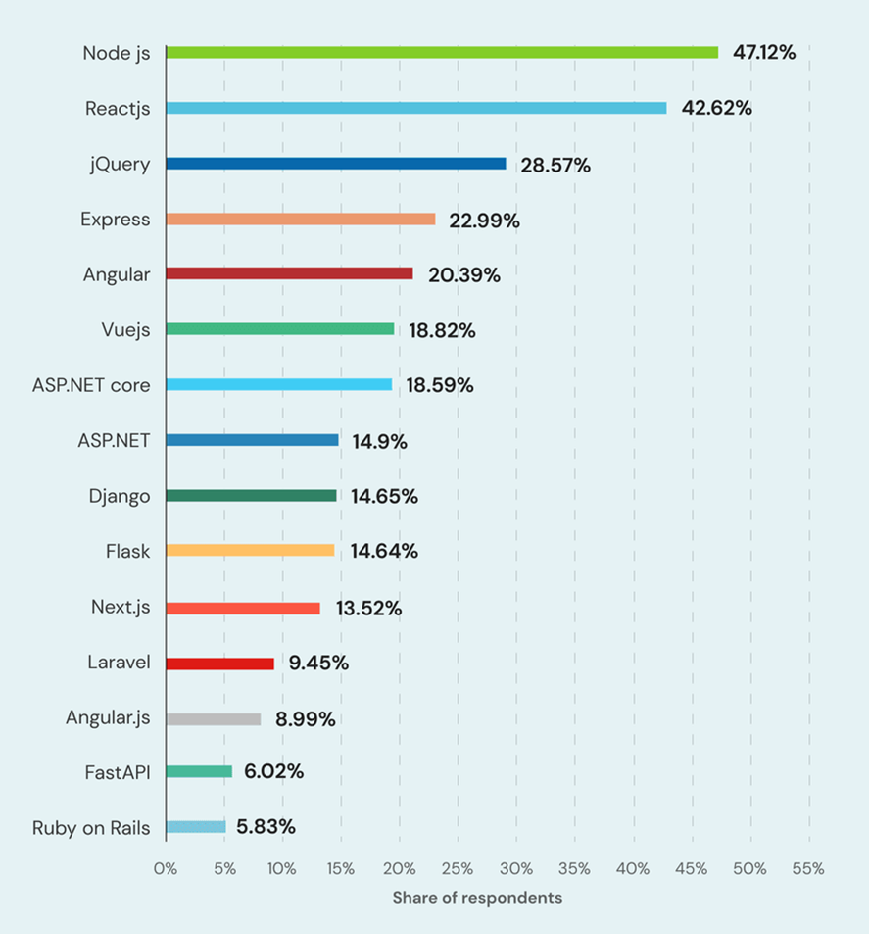

## Conceptual Model of The Study

## Based on the foregoing concepts, theories, and findings of related literature, studies presented, and insights taken from them, a conceptual model is developed as shown below

## Input

The input of the study serves as the requirements to develop the system according to the group knowledge consist of knowledge, software and hardware requirements in the knowledge requirements the researchers must acquire skills and knowledge in web developing to design and develop the system also knowledge in field of electronic learning, phonetics and phonics to develop a precise system.

## Process

Under the process it consists of methods that will conduct in developing the system sequentially first is analyzing where the group analyzes the existing learning system to create a new system in electronic or web. Second is design where the group will design the system that can be user-friendly to the users. Third is system developing and coding where the group proceeds in creating system frontend and backend. Finally, the test, debug and evaluation where the system will proceed in testing to determine the bugs and evaluate its performance.

## Output

With the input and process component the study will come up fully and a user- friendly Learning Visualized and Audio Learning Web for Phonetic Reading.

## Operational Definition of Terms

The following terms are defined to better understand the study:

**Audio Visual –** using both sight and sound, typically in the form of slides or video and recorded speech or music.

**E – Learning** – the delivery of learning and training through digital resources.

**Evaluation** – the making of a judgment about the amount, number, or value of something; assessment.

**Phoneti**c - relating to speech sounds.

**Phonic** – relating to the sounds made in speech, or to the study of these sounds.

**Pronunciation** – the way in which a word is spoken.

**Text-To-Speech –** an assistive technology kind that speaks digital text out loud. Technology for "read aloud" is another name for it. TTS may take words on a computer or other digital device and turn them into audio with the click or touch of a button.

**Voice Recognition** – the ability of a machine or program to receive and interpret dictation or to understand and perform spoken commands.

**Text-To-Speech –** an assistive technology kind that speaks digital text out loud. Technology for "read aloud" is another name for it. TTS may take words on a computer or other digital device and turn them into audio with the click or touch of a button.

**Chapter 3**

**METHODOLOGY**

This Chapter presents what the researchers employ in the study. It includes the Project Design, Project Development, Evaluation Procedure, Operation and Testing Procedure and The Diagram of the Study.

**Project Design**

The Project design of the study is discussed below using Hierarchical Input Process Output, Use Case Diagrams and System Flowchart to visualize the design and flow of the E – Learning Visualized and Audio Learning Web for Phonetic Reading

***Hierarchical Process Output***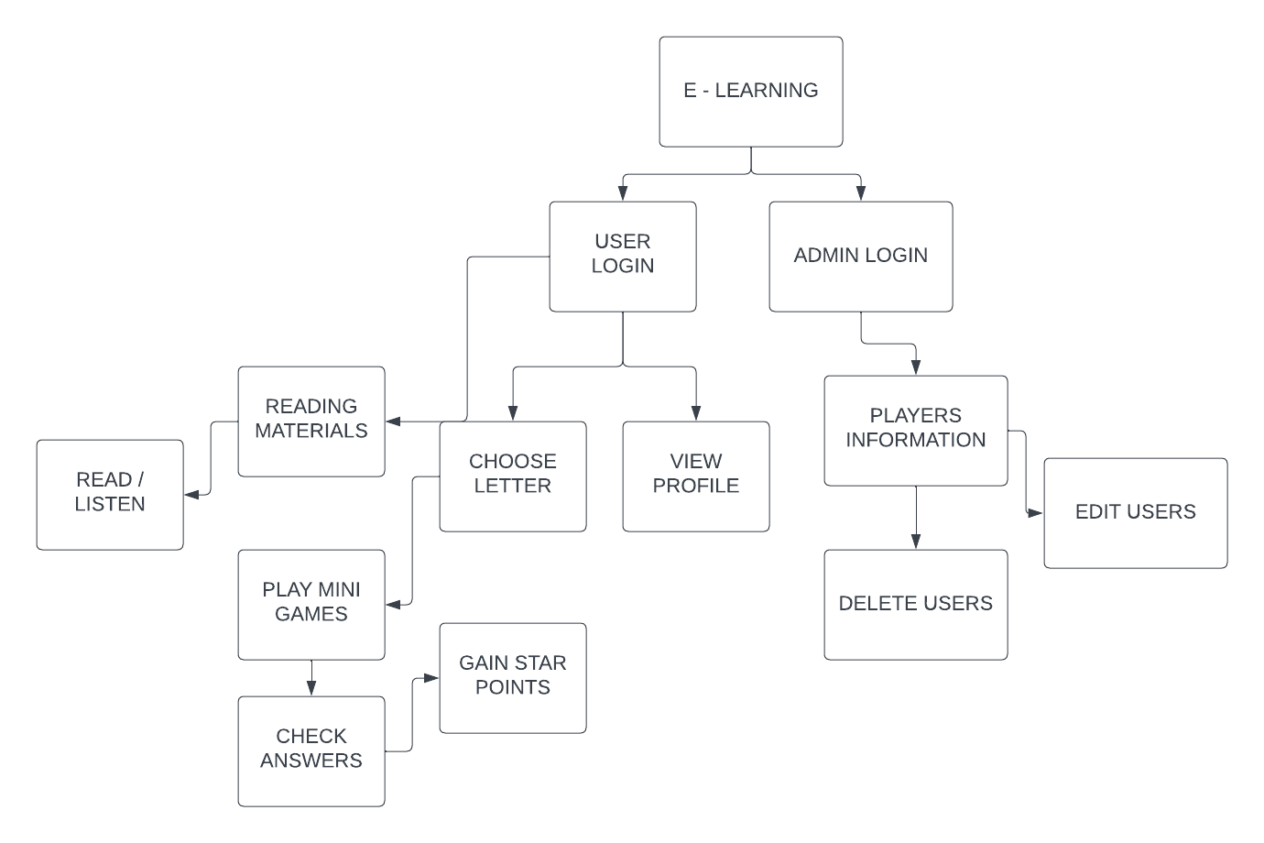

***FIGURE 1*:** Hierarchical Process Output of E – Learning Visualized and Audio Learning Web for Phonetic Reading

Figure 1 shows the hierarchical process output model of the Learning Visualized and Audio Learning Web for Phonetic Reading. Where it presents the user will log in to the website and he/she can choose to learn or play games for a phonetic reading if the user chooses the READING MATERIAL it will take the user to the audio learning page where he/she can read and listen a phonetic word from A to Z and its phonic. With this the user will learn to properly pronounce words by reading and listening to the audio phonetic learning. If the user chooses to PLAY GAMES to evaluate the learnings of the user. The user can choose a letter and start to play a variety of mini games showing the letter chosen and showing a visual picture example of the letter chosen. If the user wins the mini game the user will gain a star that will store to their profile. And this web game has a leaderboard consisting of players and their number of stars the gained and it sorts by highest to lowest stars

***System Flowchart***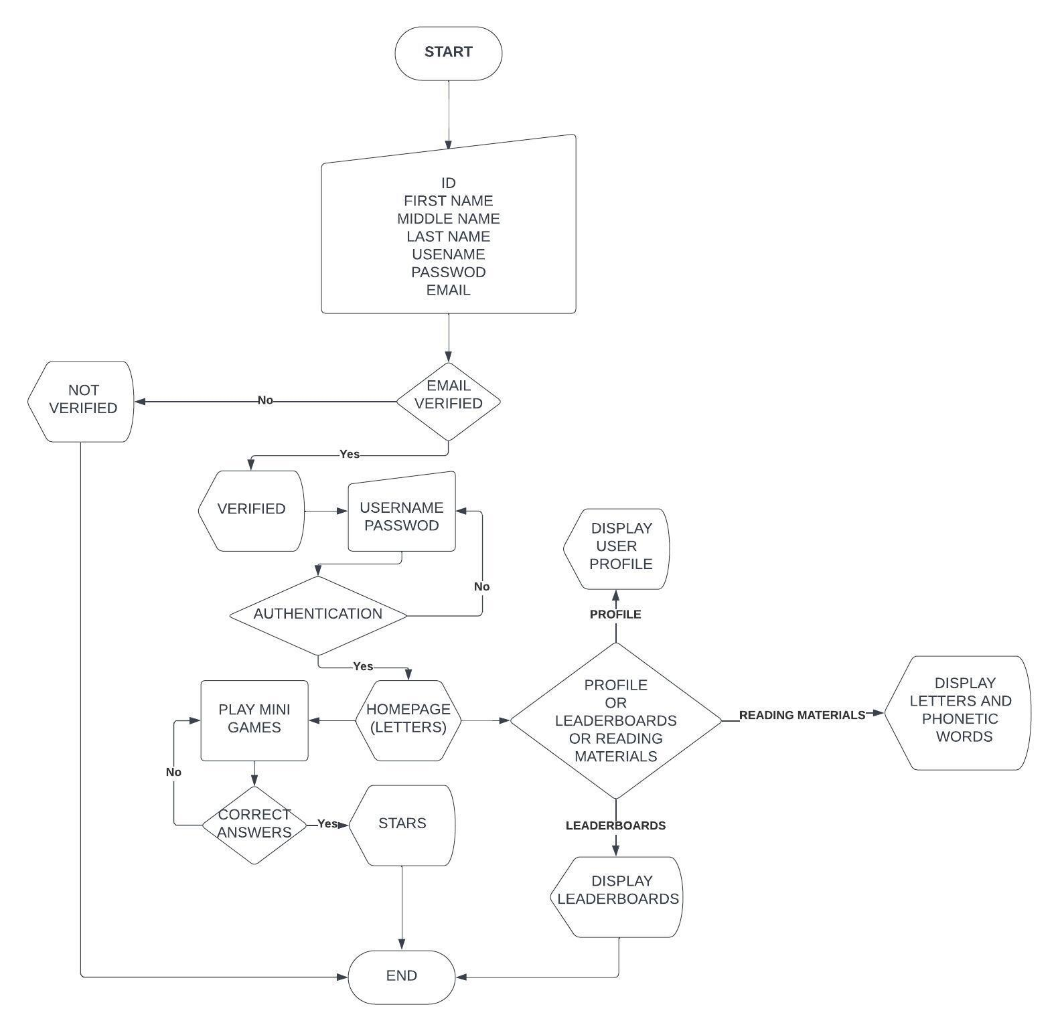

***FIGURE 2:***System Flowchart of E – Learning Visualized and Audio Learning Web for Phonetic Reading (USER)

The Figure 2 shows the flowchart of the system where the system can only be accessed if the credential is correct and verified after the registration the user can login to the login page with the users’ credentials if is authenticated the user will proceed to the home page where the user can access the mini games, user profile, practice page, reading materials and leaderboards. In the letters on the home page the user can choose a desired letter to start the mini game and play to gain a star that can be stored in leaderboards and their profile. And the user can visit their profile to modify their profile avatars and check the number of stars achieved. Also, the user can visit the leaderboards to see all the user's information and their stars and their ranks.

***Use Case Diagram***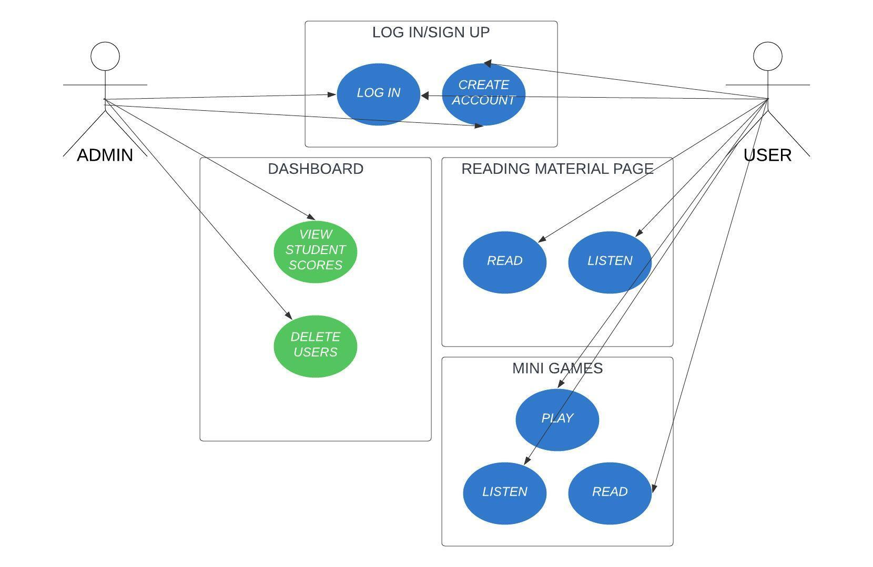

***FIGURE 4:***System Flowchart of E – Learning Visualized and Audio Learning Web for Phonetic Reading

The diagram shows the use case diagram of the system where both entities can create and log in to the web where the user can only access in the READING MATERIAL page the user can learn phonetic words by reading and listening in audio learning. Moreover, in the MINI GAMES page the user can play the phonetic games by recording the voice and matching the accuracy of pronunciation, spell the word by voice and by typing and clicking and differentiate the letter phonetics to other letter phonetics. While the admin can access the DASHBOARD and the admin can edit the profile of the students and delete and track the star points of the users.

***Database Design***

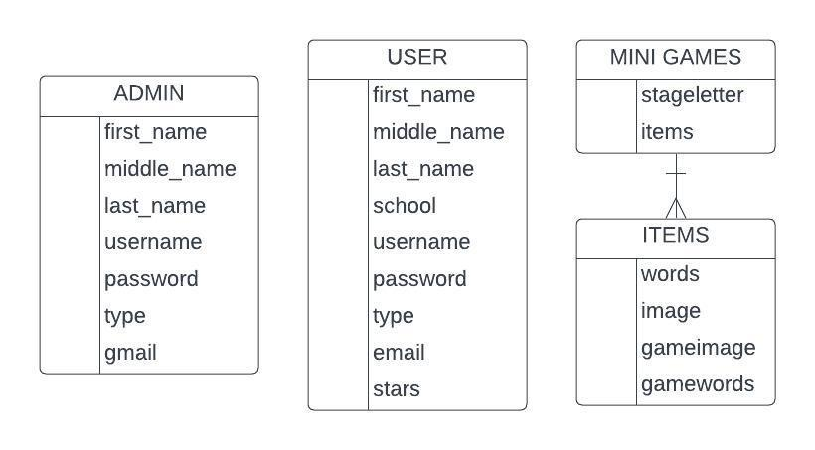

***FIGURE 5:***Database Design of E – Learning Visualized and Audio Learning Web for Phonetic Reading

The diagram shows the database design of the study consists of the entity that has been used in the system as follows. First is the admin where the admin consists of their name, and email, username and password as authentication to access the system. The admin can access the user’s data and is unable to delete and modify its information.

The second entity is the user where it consists of the name of the student and their school and lastly their authentication account username and password and Gmail to authenticate the account to access the system. And lastly the entity for the minigames of the system. The minigames where it consist of stageletter where it displays all the letter and let the user choose the letter for the minigames and the items where it is a object and consist of arrays words, image, gameimage and gamewords used for the contents of the game

**Project Development**

The system follows the agile model approach, as shown in Figure 4. The agile model consisted of three phases of development: Requirement, system design and development, testing and evaluation.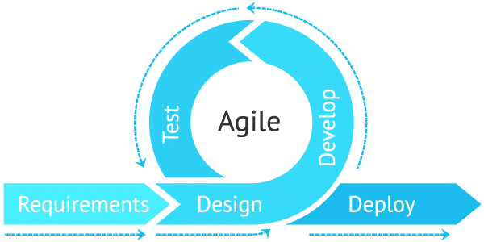

***FIGURE 6:***The Project Development Flow of E – Learning Visualized and Audio Learning Web for Phonetic Reading

***Requirement Phase***

In this phase the researchers analyze and identify the problem and formulate a solution for a learning phonetic using a manual system. The researchers found out that in learning phonetic using manual system uses papers to visualize the word and let the student read it while the teacher teaches the pronunciation of a specific word and with the combination of this problem and the technology in our generation the researchers develop a system where the student can learn an alphabet phonetic word that can access both in school and home by using a phone, PC and internet connection. With all the requirements gathered the researchers will conduct a in identifying problems continuously that can help to add a solution and turn into a feature for the system.

***Design and Develop Phase***

In this phase the researchers will proceed in designing the system to make it user-friendly for the users specially students by coding the frontend of the system. Then also the researchers will develop the system by coding the backend with a complete software and hardware to enable the system to check the pronunciation of the user to a phonetic word and generate an evaluation score for the assessment of the user with a database software installed to store all the records in database consist of user information admin information, quizzes, students answers and the results so the admin can view the scores of the students.

***Test and Deploy***

In this final phase the system will proceed on to the testing phase where the system will be tested if there will be bugs occurring during the run time. If the bug occurred in the system the researcher will maintain this bug and proceed to another testing until it perfectly runs without any bugs. After testing and maintaining the system can be now deployed to a chosen client and evaluates its performance by gathering the evaluation data on the users.

**Operation and Testing Procedure**

The following are the testing procedures undertaken to accomplish a successful developed system.

**Table 1.**

Testing Procedures (USER)

|  |  |
| --- | --- |
| **TEST ON** | **STEPS PROCEDURE** |
| 1. E – Learning Visualized and Audio Learning Web for Phonetic Reading | * Open a web browser (Chrome, Opera GX, Microsoft Edge, Mozilla Firefox. * Paste the link of the system. * Connect a speaker/mic to the computer. |
| 1. Login | * Click create account * Input the student’s id student’s name, section, and other information and username/password * Click create account * Verify email * Click the login button * Input the username and password * Click the login button |
| 1. Reading Materials | * Click the Read Material page button * Choose a letter/word. * Read and listen to audio-visual phonetic learning. |
| 1. Letters Page | * Click a letter to start mini games * Read and listen * Record the pronunciation using a microphone, record spelling using a microphone, click a letter to spell out the phonetic word, identify the letter phonetic word, type and arrange the jumbled letters * Gain a stars and store in user profile |

**Table 2.**

Testing Procedures (ADMIN)

|  |  |
| --- | --- |
| **TEST ON** | **STEPS PROCEDURE** |
| 1. E – Learning Visualized and Audio Learning Web for Phonetic Reading | * Open a web browser (Chrome, Opera GX, Microsoft Edge, Mozilla Firefox. * Paste the link of the system. |
| 1. Login | * Click create account * Input the admin’s id, name and other information and username/password * Click create account * Verify account * Click the login button * Input the username and password * Click the login button |
| 1. Dashboard Page | * Click the Dashboard page button * View the scores of the students |

**Evaluation Procedure**

To determine the evaluation of the system the researchers conduct a data survey with the 50 respondents composed of nursery students with 4 years above age in every nursery school and ask for the evaluation of the system using a survey questionnaire based on their standards and ask their parents for the recommendations to improve the system. The criteria of the evaluation for the system as follows: Functionality, Usability, Reliability and Efficiency.

The rating scale of the evaluation indicated in Table 3 as follows: “Very Satisfied” as the highest and the “Satisfied” as the second highest and “Dissatisfied” as the second lowest and lastly the “Very Dissatisfied” as the lowest rating.

The mean will be used to determine the result of the evaluation of the system using the formula below.

$\bar{x}=\frac{Σx}{n}$

= mean; n = no. of respondents; = no. of response

The mean will be computed by getting the sum of all responses and divide it by the number of respondents

After computing the mean with the scale range interpretation, the result will determine the qualitative description as follows: 3.4 – 4.0 for “Highly Acceptable;” 2.6 – 3.3 for “Very Acceptable;” 1.8 – 2.5 for “Fairly Acceptable” and 1.0 – 1.7 for “Not Acceptable.

**Table 3.**

*Rating Scale for the Evaluation Instrument*

|  |  |
| --- | --- |
| **NUMERICAL RATING** | **QUALITATIVE INTERPRETATION** |
| 4 | Very Satisfied |
| 3 | Satisfied |
| 2 | Dissatisfied |
| 1 | Very Dissatisfied |

**Table 4.**

*Scale Range and the Qualitative Interpretation*

|  |  |
| --- | --- |
| **NUMERICAL RATING** | **QUALITATIVE INTERPRETATION** |
| 3.4 – 4.0 | Highly Acceptable |
| 2.6 – 3.3 | Very Acceptable |
| 1.8 – 2.5 | Fairly Acceptable |
| 1.0 – 1.7 | Not Acceptable |

**Chapter 4**

**RESULTS AND DISCUSSION**

This Chapter outlines the project description, the project structure, capabilities and limitations, the evaluation results for the project and it concludes with a detailed review of the findings that have been achieved through meticulous project assessment.

**Project Description**

This web-based application has a user-friendly interface which has been customized to involve the kids within the learning process and to make the learning to be an enjoyable and interactive one. This system offers mini games for children to better engage and listen to speakers pronounce words correctly, visual learning such as graphics, and animation making the learning experience multisensory. Also, it has one important feature which is accessibility, allowing kids to learn at their own pace.

**Project Structure**

The following figure presents the different pages of E – Learning Visualized and Audio Learning Web for Phonetic Reading where in the Figure 7-10 is the sign up and login form to have authentication to the e-learning system. While in Figure 11-17 are the main pages for the e-learning system.

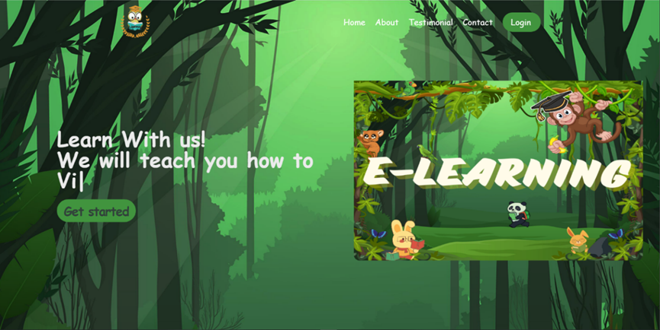

***FIGURE 7:***Home Page

Figure 6 depicts the homepage of the system. It is an overview of the app’s purposes and highlights the key features of the system. The users can gain visual understanding on how the system will work and also to know the navigation structure.

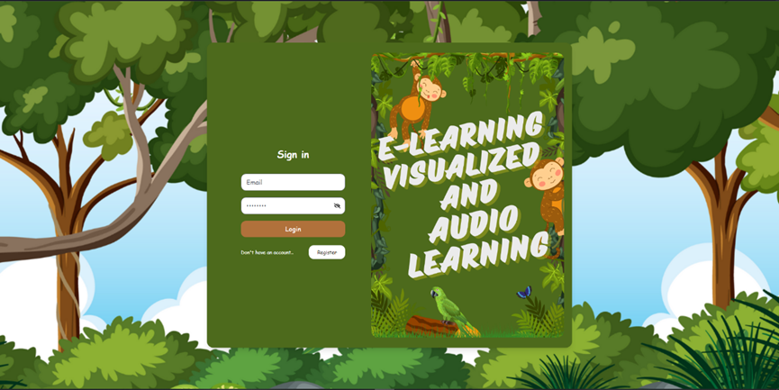 ***FIGURE 8:***Login Form

After clicking the login button, users can choose between signing if they already have one or register for a new account. The procedure is as shown in Figure 7.

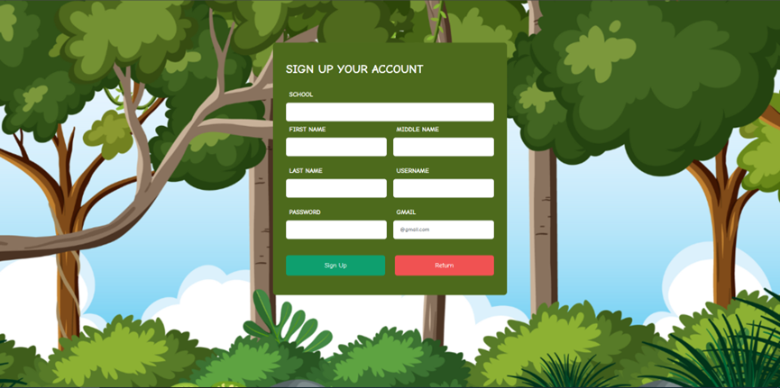***FIGURE 9:***Registration Form

In Figure 8, if the user doesn’t have an account, he/she can create an account by providing his/her details to process the registration.

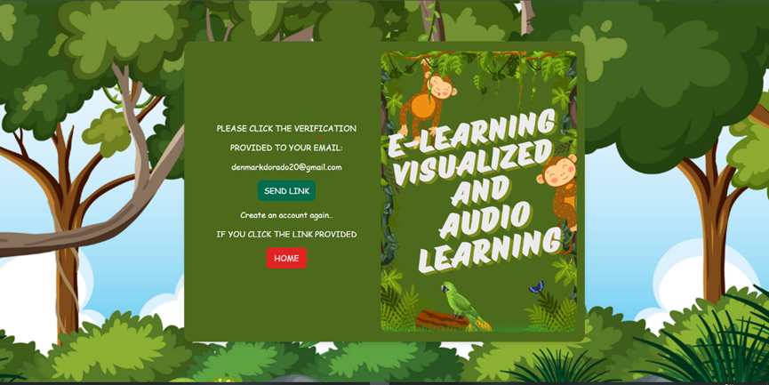***FIGURE 10:*** VerificationPage

In figure 9, after filling out the required credentials, there is a verification link that will send in the user’s registered g-mail account. After he/she receives the verification link and clicks the link, the user will proceed to log in.

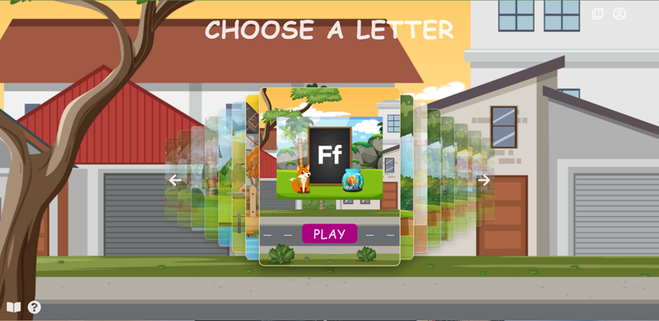***FIGURE 11:*** LetterPage

Figure 10 showcases the letter page, presenting users with a dynamic carousel of various letters. This interactive tool improves language learning by letting users choose which letters they want to learn how to pronounce correctly.

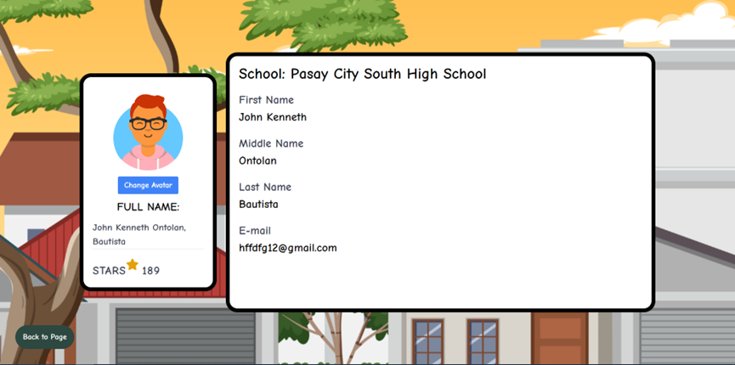***FIGURE 12:*** User Profile

Figure 11 depicts the user’s profile. It contains the credentials such as section, full name, e-mail, avatar and stars. If the user doesn’t like the avatar, he/she can change it by clicking the button “Change Avatar”.

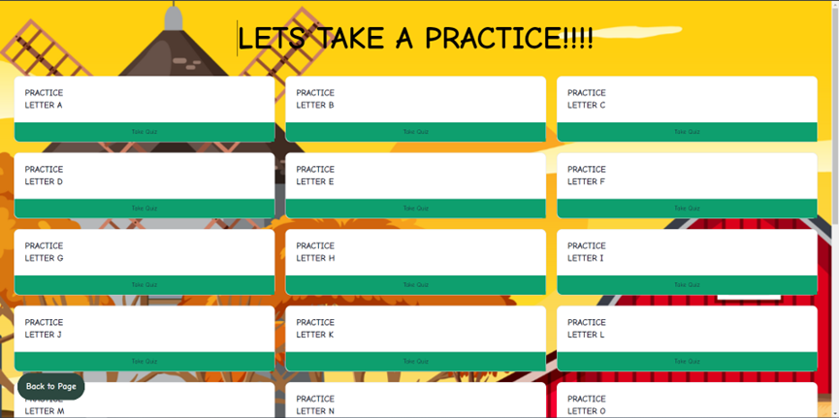

***FIGURE 13:*** Practice Page

Figure 12 show the practice page for the users to enhance their speech pronunciation with the variation of words according to its letter

**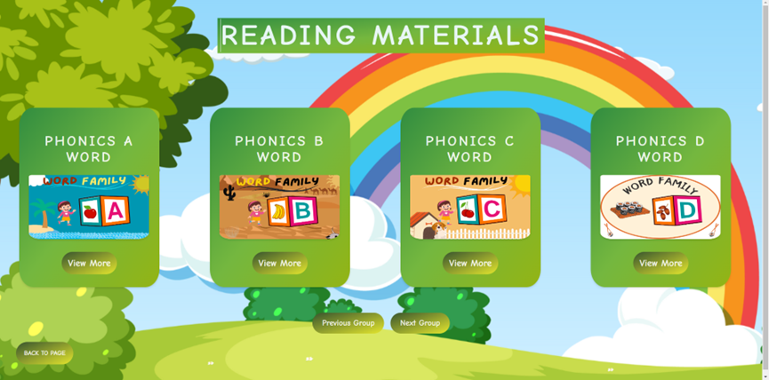*FIGURE 14:*** Reading Material Page

In Figure 14, the page consists of phonic words that can be viewed by the user to study the variation of words in every letter.

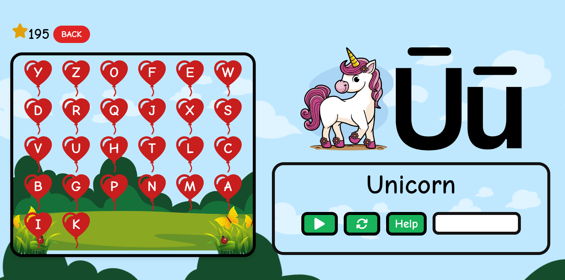***FIGURE 15:*** Pop The Balloon

In figure 13, it shows a mini game called “Balloon Game”. It is a spelling game but the user needs to pop the balloon to spell out the given image

.***FIGURE 15:*** Say The Word

In figure 15, This game is called “Say The Word” and tests their pronunciation speech by answering the correct pronunciation of the given word using the mic.

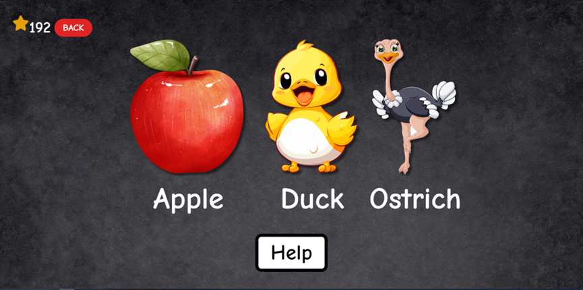***FIGURE 16:*** Pick The Word

In figure 15, This game is called “Pick The Word” where the user chooses between the three (3) images that are based on the given alphabet in the previous game.

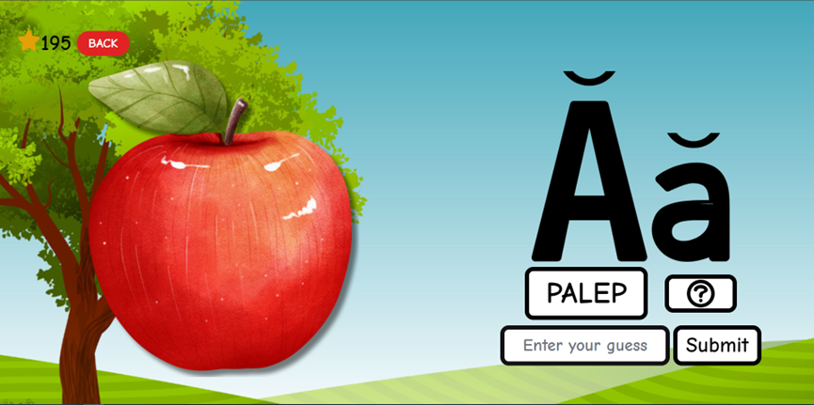***FIGURE 17:*** Guess The Word

In figure 15, This game is called “Guess The Word” where the user arranges the jumbled letters to provide the correct arrangement of the letters.

**Project Capabilities and Limitations**

The developed system has the following capabilities:

1. The system provides reading materials and practices for learners.
2. Text is converted into spoken words by the technology, making e-learning information accessible to learners.
3. The system creates multimedia presentations that combine text, images, videos, animations, and interactive elements to convey complex concepts effectively.
4. The system offers entertaining minigames to play, adding enjoyment and interactivity to the learning process.
5. The system can be used through mobile phones allowing learners to access audio-based content on smartphones or tablets anytime, anywhere.
6. The system produces human-like speech with intonation and correct pronunciation and it enhances the listening experience for learners.
7. The system provides an array of expertly designed visual and audio elements to improve the process of learning.
8. The system includes gamified components like stars to increase learner motivation and engagement.
9. The systems can dynamically adapt content based on individual learner preferences or needs. For example, learners may choose different phonics and letters, allowing them to personalize their learning experience for optimal comprehension

The developed system has the following limitations:

1. The system requires the internet to run.
2. The lowest resolution of the system can use is 640x
3. The engagement and comprehension may be affected by the generated voice's continued absence of the natural intonation, accent, and emotion of human speech.
4. The system may fail to comprehend the text's context, which could lead to errors or an incorrect target specific words.
5. The system speech recognition accuracy can vary depending on factors such as accent, pronunciation, background noise, and language complexity, leading to errors in transcription.
6. The system’s microphone turns off automatically within 3 seconds once the mic is turned on, so speak immediately.
7. Users may experience frustration and disruptions in their learning process due to technical issues or glitches in the system, which could include mispronunciations, delays in audio playing, or system crashes.
8. The system can’t adjust the difficulty of the games or learning materials, it is just built for kids to learn to identify things and words.

## Project Evaluation

## This part includes information gathered during system or framework testing, with an emphasis on functional suitability and security. It provides a comprehensive study of how the system satisfies functional objectives while also addressing possible security risks. Furthermore, it includes and assesses the project's evaluation results, providing insights into overall performance and areas for improvement. The results are organized to emphasize significant perceptions, recommendations, and suggestions.

## Functional Suitability Test Results

## The system's functional suitability was assessed using test case scenarios for various framework or system actors. Table 5 provides a detailed description of these conducted test scenarios, together with their findings in terms of usable reasonableness. This table illustrates the specific capabilities tested for each actor, demonstrating the framework's vigor and consistency over a wide range of client interfaces.

## 

## Table 5.

*Testing Procedure for Functional Suitability in terms of students and admin*

|  |  |  |
| --- | --- | --- |
| **TEST CASE** | **STEPS UNDERTAKEN** | **RESULTS** |
| **Sign Up Process**  **Login** | 1. Open a web browser (Chrome, Opera GX, Microsoft Edge, Mozilla Firefox. 2. Paste the link of the system 3. Click the button ‘register’ 4. Input school id, name and other information and username/password 5. Click create account 6. Verify account 7. Click login button 8. Input the username and password 9. Click the login button | **PASSED** |
| **Reading Materials** | 1. Click the reading material page button. 2. Choose a letter/word. 3. Read and listen to audio visual phonetic reading | **PASSED** |
| **Letter Page** | 1. Click a letter to start the game. 2. Read and listen 3. Record the pronunciation using a microphone, record spelling using a microphone, click a letter balloon to spell out the   phonetic word, identify the letter phonetic word, type and arrange the jumbled letters.   1. Gain a star and store in the user profile. | **PASSED** |
| **Navigation** | 1. Click on each navigation button: Reading material, practice page and menu. 2. Navigate back to the letter page. | **PASSED** |
| **Login Admin** | 1. Go to the login page. 2. Click the “Select type use” then click admin. 3. Click the login button | **PASSED** |

**Security Test Results**

**Table 6.**

*Testing Procedure for Security*

|  |  |  |
| --- | --- | --- |
| **TEST CASE** | **STEPS UNDERTAKEN** | **RESULTS** |
| **Login Authentication** | 1. Attempt to login invalid credentials. 2. Attempt to login valid credentials. | **PASSED** |
| **Password Strength** | 1. Attempt to set a weak password | **PASSED** |
| **Login Authentication Admin** | 1. Attempt to login invalid credentials | **PASSED** |

**Evaluation Results**

The developed web application was evaluated by Teachers, Parents and even the child’s guardians. A total of 50 respondents from this group evaluated the system according to ISO/IEC 25010 in terms of User Experience, Content Evaluation, Technical Aspects and Overall Satisfaction, resulting in a weighted average grade of 3.73. The overall weighted mean rating is considered “Very Satisfied” since it lies between 3.26 and 4.0 on the scale.

**Table 7.**

*User Experience Evaluation Result*

|  |  |  |
| --- | --- | --- |
| **Criteria** | **Weighted Mean** | **Descriptive Rating** |
| Ease of Navigation | 3.76 | Highly Acceptable |
| Design and Layout | 3.86 | Highly Acceptable |
| Content Accessibility | 3.80 | Highly Acceptable |
| **Overall Weighted Mean** | **3.81** | Highly Acceptable |

Table 39 shows that the system's ease of navigation received a weighted mean score of 3.76, which corresponds to a descriptive evaluation of "Very Acceptable" or "Very Satisfied." This suggests that the built web application effectively handled the ease of navigation. As a result, users considered the system simple and intuitive, presumably contributing to a favorable overall user experience.

Regarding its design and structure, the created web app was given a score of 3.86, which is equivalent to a rating of "Highly Accepted" or "Very Satisfied" according to the ISO/IEC 25010 guidelines. This high score shows that the app's design is both effective and attractive, fulfilling what users expect in terms of both looks and how it works. The positive comments show that users enjoyed the app's visuals and found its structure easy to navigate, making it simple to use. This excellent performance in design and structure not only improves the user experience but also indicates that the app is well-made to cater to the varied needs of the users.

In terms of content accessibility, the created web application received a score of 3.80, which corresponds to a descriptive level of "Highly Accepted" or "Very Satisfied." This score emphasizes that the content was easily accessible and engaging for users, which is critical for providing a smooth and welcoming experience to all. The positive rating for content accessibility shows that the application successfully serves a wide audience by making information easily accessible and streamlining the navigation experience. This feature most likely contributes significantly to the application's overall ease of use and user satisfaction.

The built web application had an overall weighted mean of 3.81 and a descriptive grade of "Highly Accepted" or "Very Satisfied" for user experience evaluation. This high grade suggests that the program satisfies user expectations on several levels of usefulness and satisfaction. The positive rating emphasizes the application's ability to provide a seamless, intuitive, and engaging user experience, reflecting the quality and attention to detail put into the application's development.

**Table 8.**

*Content Evaluation Result*

|  |  |  |
| --- | --- | --- |
| **Criteria** | **Weighted Mean** | **Descriptive Rating** |
| Content Quality | 3.80 | Highly Acceptable |
| Content Relevance | 3.80 | Highly Acceptable |
| Interactivity | 3.74 | Highly Acceptable |
| **Overall Mean** | **3.78** | Highly Acceptable |

In the Content Evaluation section of Table 40, the system achieved a weighted average score of 3.80 for Content Quality, corresponding to a descriptive rating of “Highly Accepted” or "Very Satisfied." This rating suggests that the users were highly pleased with the system's content, finding it to be of superior quality that fulfilled their expectations and requirements effectively. The high score reflects the comprehensiveness, relevance, and accuracy of the information provided. It's likely that users appreciated the clarity and depth of the content, which played a significant role in their satisfaction and confidence in the system. This positive performance in content quality highlights the system's capability to generate relevant and reliable information, enhancing the user experience and ensuring that the content is both informative and engaging.

Regarding the Relevance of Content, the system achieved a score of 3.80 on a weighted scale, corresponding to a descriptive satisfaction level of "Highly Accepted" This score suggests that the content was found to be highly relevant and in line with what users were looking for and interested in. The favorable score points out that the information given by the system was not just correct but also relevant and beneficial to the users. Such relevance guarantees that users can depend on the system for current and relevant information, thus improving their overall experience and interaction with the application. The favorable remarks about the relevance of content highlight the system's success in providing information that is significant and tailored to the needs of its users.

Regarding Interactivity, the system achieved a weighted average score of 3.74, reflecting a descriptive score of "Highly Accepted." This notable score indicates that participants were highly pleased with how interactive and captivating the system was. The favorable responses indicate that the application offers a vibrant and quick response interface, enabling users to engage with the content and features easily. The system's interactivity likely improves the overall experience for users by making it straightforward to navigate and actions effortless, which helps to maintain user interest and satisfaction with their interactions. The solid performance in this aspect highlights the application's ability to support meaningful engagement among users through effectively designed interactive features.

The developed web application received a weighted average score of 3.78 in the content evaluation category and a descriptive rating of "Highly Accepted" or "Very Satisfied". This high rating means that users think it is high quality, comprehensive and well suited to their needs.

**Table 9.**

*Technical Aspects Evaluation Results*

|  |  |  |
| --- | --- | --- |
| **Criteria** | **Mean** | **Descriptive Rating** |
| Platform Reliability | 3.58 | Highly Acceptable |
| **Overall Mean** | **3.58** | Highly Acceptable |

Table 41 offers a concise overview of the Technical Aspects Evaluation. The assessment resulted in a final weighted average score of 3.89, with a descriptive grade assigned as "Highly Accepted" or "Very Satisfied" for Platform Reliability. This favorable score suggests that users viewed the platform as highly dependable and performed well consistently. Importantly, no complaints or crashes were made, showing the app's dependability and toughness. Users noted perfect operation, aiding in their total contentment with the app's technical features.

**Table 10.**

*Overall Satisfaction Evaluation Results*

|  |  |  |
| --- | --- | --- |
| **Criteria** | **Mean** | **Descriptive Rating** |
| Overall Satisfaction    Recommendation | 3.74    3.78 | Highly Acceptable    Highly Acceptable |
| **Overall Mean** | **3.76** | Highly Acceptable |

In the Overall Satisfaction Evaluation section of Table 40, the system achieved a weighted average score of 3.74 for Overall Satisfaction, corresponding to a descriptive rating of "Highly Accepted." This score reflects a high level of user contentment with the system's performance, functionality, and overall user experience. Users found the interface intuitive and the features comprehensive, contributing to a seamless and enjoyable interaction with the system. The positive feedback indicates that the system effectively meets user expectations and requirements, enhancing their overall experience and satisfaction. The high satisfaction rating underscores the system's success in delivering a user-centric and reliable solution.

In terms of Recommendation, the developed web app was given a rating of 3.78, which falls within the descriptive range of "Highly Accepted" or "Very Satisfied." This score suggests that users are very likely to endorse the app to others, showing their confidence in its quality and functionality. The high score for the app's recommendation highlights its outstanding reputation and the trust users place in it. The app was perceived as reliable, easy to use, and successful in addressing the users' requirements, leading them to become strong advocates for it. Their eagerness to recommend it to peers and colleagues indicates the app's success in delivering a rewarding and advantageous experience for users.

The created web app got an average score of 3.76 in the Overall Satisfaction Evaluation section, leading to a descriptive rating of either "Highly Accepted" or "Very Satisfied." This suggests that users are extremely pleased with how the app works and what it offers. Users were very happy with how easy the app was to use, how helpful it was, and their overall experience with it. The positive rating shows that the app meets user needs and expectations well, which plays a big role in its success and use.

**Chapter 5 SUMMARY OF FINDINGS, CONCLUSIONS, AND RECOMMENDATIONS**

This chapter presents the summary of findings, conclusions, and the corresponding recommendations based on the results of the system's testing and evaluation.

**Summary of Findings**

The system is intended to assist children learn reading, pronunciation, spelling, and object recognition. Furthermore, it employs cutting-edge technologies to improve the learning experience. Children can access the online application from anyplace with an internet connection if they are accompanied by instructors, parents, or guardians. This platform facilitates studying outside of school hours and even prepares children before they begin formal schooling.

The platform offers dynamic lessons and captivating tasks designed to enhance the learning experience. It encompasses customized learning routes crafted for the specific requirements and advancement of every student. By providing instant feedback and adjustable tasks, students are encouraged to reach their educational objectives. Additionally, the application incorporates multimedia components like pictures, animations, and games to establish an engaging learning atmosphere.

Moreover, the system tracks the progress of every child, producing detailed information for teachers and guardians, enabling them to identify areas that need improvement. This comprehensive strategy ensures that children develop a strong base in reading and mental skills, setting them up for future educational achievements.

By analyzing the evaluation results for the acceptability of the web application titled “E – Learning Visualized and Audio Learning Web for Phonetic Reading”, the application will greatly teach the users, and will offer an interactive learning throughout the learning experience.

The actual result of the test demonstrates the system’s user experience, content evaluation, technical aspect, and overall satisfaction. The user experience of the system was further defined by its ease of navigation, design and layout, and content accessibility was evaluated as “Highly Accepted”. This signifies that the system was also emphasized, including its consistency, user-friendliness, and reactivity. According to user comments, the platform's overall visual appeal, smooth integration of functionality, and clear feature labeling all received good marks. These components made a big difference in the user experience, making it effective and enjoyable.

The content evaluation of the system was further defined by its content quality, relevance and interactivity was evaluated as “Very Satisfied” or “Highly Accepted”. The system's broad and up-to-date resources, engaging multimedia features, and customized content suggestions were also highly regarded. The accuracy and depth of the content, its ease of access to pertinent information, and its interactive features which enhanced learning and involvement were all appreciated by users. These aspects significantly contributed to the positive evaluation of the system's content.

When it comes to technical aspects, the rating of the platform reliability was “Very Satisfied”/”Highly Accepted”. Moreover, the system's steadiness, processing speed, and security features received widespread praise. Users experienced little to no interruptions, rapid page loading, and strong data security practices. The system's ability to manage extensive data amounts and its compatibility with different devices and operating systems were also highlighted as major advantages. These technical qualities were instrumental in building user confidence and improving satisfaction with the system.

Lastly, when it comes to overall satisfaction, the rating of the system was “Very Satisfied” or in other terms “Highly Accepted”. The level of satisfaction shows that the system excels across various areas, such as how easy it is to use, its design and organization, how accessible the content is, the quality of the content, how relevant it is, how it allows for interaction, and how reliable the technology is. Users commended the system's smooth blending of features, easy-to-understand interface, and steady performance. Overall, positive comments in every area highlight the system's success in meeting user needs and expectations, leading to a top-notch user experience.

**Conclusion**

The conclusion derived as follows

1. The E-learning system provides the following features:

a) The E-learning system allows user to learn and enhance their phonetic reading through playing variety games using computer and mobile devices

b) Every game can generate a star score system that can be achieved in every corrected answers

c) Can save and view the star scores

d) Can view the reading materials for phonetic learning

e) Practice system that can improves user phonetic pronunciations

1. The E-learning system was successfully developed using NodeJs, ReactJs together with the Tailwind as CSS framework and other editing software for the contents
2. The E-learning system is well tested by its functionality
3. E-learning system gained the overall satisfactory mean score of “3.74” interpreted as “Very Satisfied”

**Recommendations**

To further enhance the capabilities and potentials of the developed system as identified by the conducted survey, the following suggestions are as follows:

**References**

Cai, H. (2012). E-learning and English teaching. *IERI Procedia*, *2*, 841–846. <https://doi.org/10.1016/j.ieri.2012.06.180>

*Phonics and Word Recognition Instruction in Early Reading Programs: Guidelines for Children with Reading Disabilities | Reading Rockets*. (n.d.). Reading Rockets. <https://www.readingrockets.org/topics/phonics-and-decoding/articles/phonics-and-word-recognition-instruction-early-reading>

Bates, A. W. (2004). *Managing technological change: strategies for college and university leaders*. <http://ci.nii.ac.jp/ncid/BA53167915>

Ai-Xia, D. (2011). Factors influencing learner attitudes toward e-learning and development of e-learning environment based on the integrated e-learning platform. *International Journal of e-Education, e-Business, e-Management and e-Learning*. <https://doi.org/10.7763/ijeeee.2011.v1.43>

Zhang, W., & Cheng, Y. L. (2012). Quality assurance in e-learning: PDPP evaluation model and its application. *The International Review of Research in Open and Distributed Learning*, *13*(3), 66. <https://doi.org/10.19173/irrodl.v13i3.1181>

Fee, K. (2012). Delivering e-learning. A complete strategy for design, application and assessment. *Development and Learning in Organizations*, *27*(1). <https://doi.org/10.1108/dlo.2013.08127aaa.013>

Radović-Marković, M. (2010). Advantages and disadvantages of e-learning in comparison to traditional forms of learning. *Annals of the University of Petrosani: Economics*, *10*(2), 289–298. <https://upet.ro/annals/economics/pdf/2010/20100227.pdf>

Jethro, O. O., Grace, A. M., & Thomas, A. K. (2012). E-learning and its Effects on Teaching and Learning in a Global Age. *International Journal of Academic Research in Business and Social Sciences*, *1*(2), 73–78.

Boulos, M. N. K., Maramba, I., & Wheeler, S. (2006). Wikis, blogs and podcasts: a new generation of Web-based tools for virtual collaborative clinical practice and education. *BMC Medical Education*, *6*(1). <https://doi.org/10.1186/1472-6920-6-41>

Taja-On, E., Miras, R., & Jurolan, C. (2021). E-Learning: Teaching Effectiveness to Conventional Teaching in Undergraduates amid COVID-19 Pandemic. *OAlib*, *08*(11), 1–10. <https://doi.org/10.4236/oalib.1108124>

Dizon, R. (2019, January 18). *Phonics Instructional Materials in Filipino: Input for managing instructions for improved reading competencies*. <https://ojs.aaresearchindex.com/index.php/AAJMRA/article/view/8242>

Tms, D. (n.d.). *E-learning as an aid to reading*. DynDevice. <https://www.dyndevice.com/en/news/e-learning-as-an-aid-to-reading-ELN-1624/>

*SCIRP Open Access*. (n.d.). <https://www.scirp.org/journal/paperinformation.aspx?paperi>

Truelogic. (2023). Educational apps aim to make learning more fun in the Philippines. *Truelogic*. <https://www.truelogic.com.ph/blog/educational-apps-aim-make-learning-fun-philippines/>

Alviz, A. A. (2018, August 1). *Utilizing Game-based learning in Explicit Instruction for Early Grades Reading Fluency*. GRIN. <https://www.grin.com/document/436031>

Brittany Kasprick. (2022). *The Effectiveness of Using Phonics Instruction and Inter eness of Using Phonics Instruction and Interventions entions in Elementary Classrooms*.

Garcia, B., & Mangaba, B. (n.d.). *DELIVERING EFFECTIVE DIGITAL GAMEBASED LEARNING: A COMPARATIVE STUDY BETWEEN COMPUTER AND MOBILE AS THE LEARNING FRAMEWORK FOR PRESCHOOLERS*.

Rosenkrantz, H. (2021, August 30). When do kids learn to read? *US News & World Report*. <https://www.usnews.com/education/k12/articles/when-do-kids-learn-to-read>

De Vera, B. O. (2022, April 1). *Lockdown’s impact: Unicef cites poor reading skills among PH kids | Inquirer News*. INQUIRER.net. <https://newsinfo.inquirer.net/1576573/lockdowns-impact-unicef-cites-poor-reading-skills-among-ph-kids>

Gooch & A. Lambirth (Eds.), *Understanding phonics and the teaching of*

*reading: Critical perspectives* (pp. 75-87). Buckingham, GBR: Open University Press. Retrieved September 6, 2012, from [http://site.ebrary.com/lib/dominicanuc/Doc?id=id10229870&ppg=86.](http://site.ebrary.com/lib/dominicanuc/Doc?id=id10229870&ppg=86)

Ehri, L. C., Nunes, S. R., Stahl, S. A., & Willows, D. M. (2001). Systematic phonics

instruction helps students learn to read: Evidence from the national reading panel's meta-analysis. *Review of Educational Research*, *71*(3), 393-447. Retrieved from <http://www.jstor.org/stable/3516004>

Shabiralyani, G., Hasan, K. S., Hamad, N., & Iqbal, N. (2015). Impact of visual aids in enhancing the learning process Case research: District Dera Ghazi Khan. *Journal of Education and Practice*, *6*(19), 226–233. <http://files.eric.ed.gov/fulltext/EJ1079541.pdf>

Kurniawati, J. (2023, February 18). The influence of E-Learning Media in the PBL approach to participants’ interest and learning achievement. <https://jonedu.org/index.php/joe/article/view/1874>

Khan, R., Ali, A. & Alourani, A. (2022). Investigating Learners' Experience of Autonomous Learning in E-learning Context. International Journal of Emerging Technologies in Learning (iJET), 17(8), 4-17. Kassel, Germany: International Journal of Emerging Technology in Learning. Retrieved October 14, 2023 from <https://www.learntechlib.org/p/222832/>.

Zotov, V., Ibrahim, I., Petunina, I., & Lazareva, Y. (2021). Retracted Article: Engagement of Students in Data Visualization for the Purpose of E-Learning Improvement. International Journal of Emerging Technologies in Learning (iJET), 16(02), pp. 46–64. <https://doi.org/10.3991/ijet.v16i02.18745>

Rawashdeh, A. Z. A., Mohammed, E. Y., Arab, A. R. A., Alara, M., & Al-Rawashdeh, B. (2021, May 17). Advantages and disadvantages of using e-learning in university education: Analyzing students’ perspectives. Electronic Journal of e-Learning. <https://academic-publishing.org/index.php/ejel/article/view/2168>

Rajak, S. (n.d.). 5 reasons to use Tailwind. www.linkedin.com. <https://www.linkedin.com/pulse/5-reasons-use-tailwind-saurav-rajak>

Modan, S. (n.d.). *Benefits And Reasons To Choose Reactjs For Your Project*. Peerbits. <https://www.peerbits.com/blog/reasons-to-choose-reactjs-for-your-web-development-project.html>

Ana María Fernández-Pampillón, & Antonio Pareja-Lora. (2017). e-Vocabulary and e-Learning. Education Sciences, 7(1), 34–34. doi:10.3390/educsci7010034

Daniel Strmečki, Andrija Bernik, & Danijel Radošević. (2015). Gamification in E-Learning: Introducing Gamified Design Elements into E-Learning Systems. Journal of Computer Science, 11(12), 1108–1117. doi:10.3844/jcssp.2015.1108.1117

Abdulaziz Omar Alsadhan, Sami M. Alhomod, & Mohd Mudasir Shafi. (2014). Multimedia Based E-learning : Design and Integration of Multimedia Content in E-learning. International Journal of Emerging Technologies in Learning (Ijet), 9(3), 26–26. doi:10.3991/ijet.v9i3.3308

Azieva Tumaris, & Khadjieva Dilbar. (2023). TEACHING READING THROUGH PHONETIC ACTIVITIES TO YOUNG CHILDREN. Zenodo (Cern European Organization for Nuclear Research). doi:10.5281/zenodo.7883840

Indriana W.W, & Suparno. (2019). Using Phonetic Methods for Children’s Reading Ability Development in Kindergarten. doi:10.2991/icsie-18.2019.47

Gillian Kopp, & H. C. Green. (1946). Basic Phonetic Principles of Visible Speech. Journal of the Acoustical Society of America, 18(1), 244–245. doi:10.1121/1.1902423

Francesco Caviglia, & Maria Ferraris. (2008). The Web as a learning environment. Springer Ebooks, 175–178. doi:10.1007/978-0-387-09729-9_27

Balachandran, A. B., & Mahalakshmi, T. (2023, September 9). *E-Learning*. ResearchGate. <https://www.researchgate.net/publication/373815150_E-Learning>

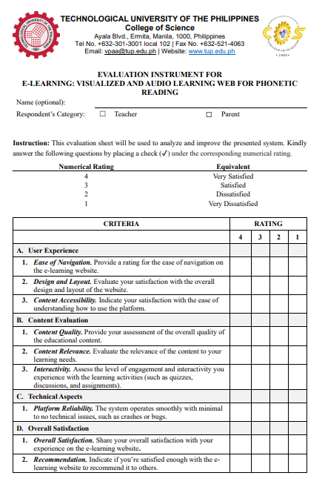**Appendix A**

**EVALUATION INSTRUMENT**

**Appendix B**

**SAMPLE ANSWERED EVALUATION SHEET**

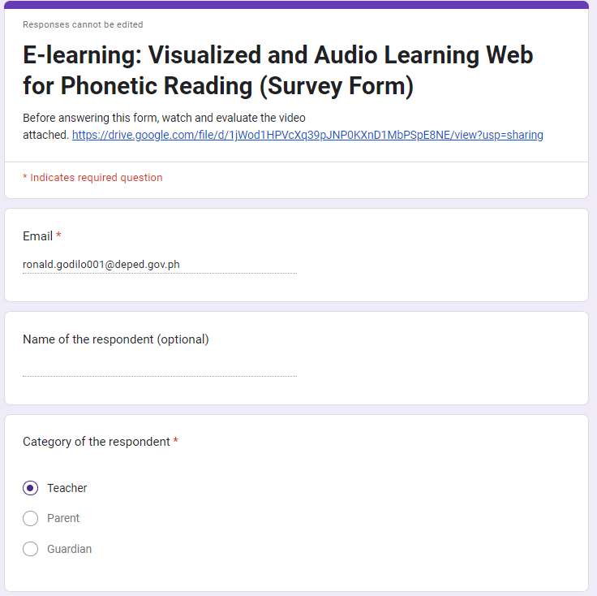

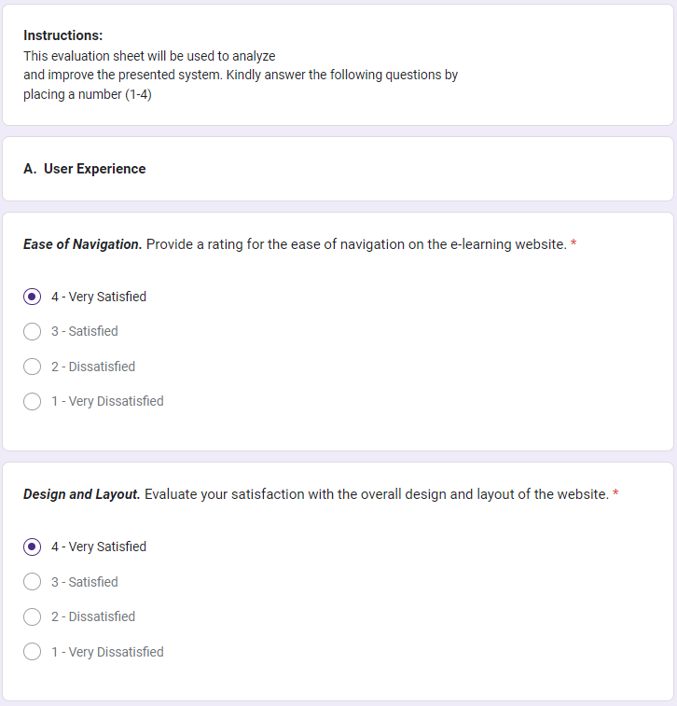

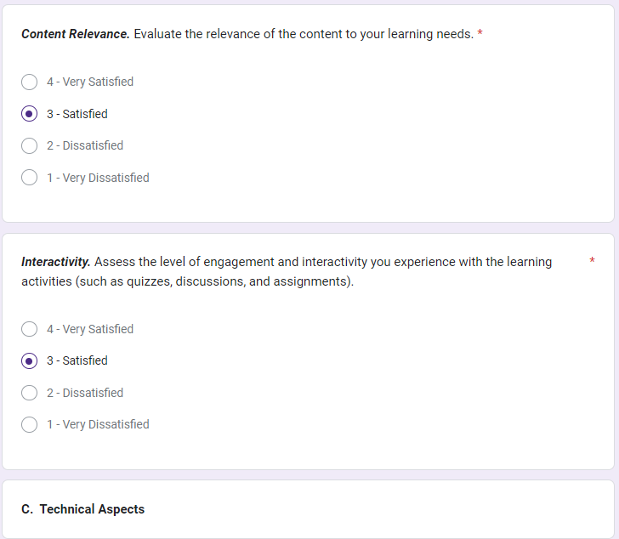

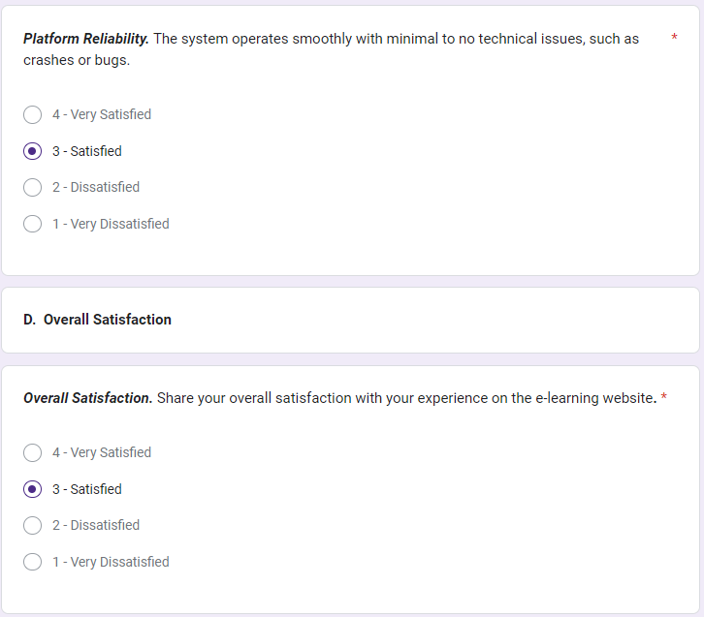

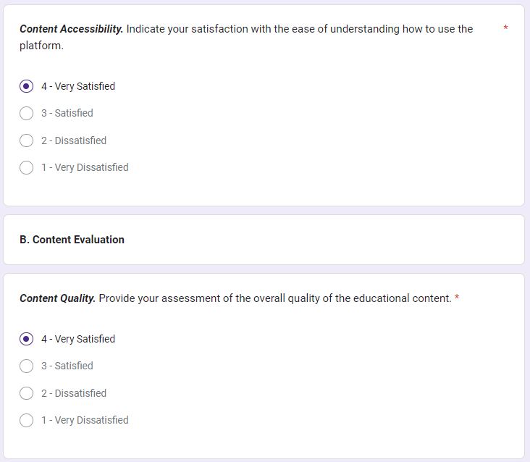

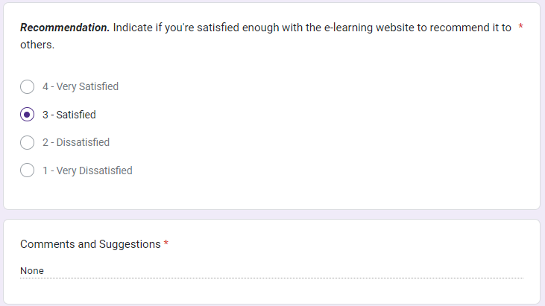

**Appendix C**

**SUMMARY OF RESPONDENTS’ EVALUATION**



**Appendix D**

**TEST CASES FOR FUNCTIONAL SUITABILITY**

|  |  |  |
| --- | --- | --- |
| **Test Case ID:** | **ELVALWPR-USE-FUN-001** |  |
| **Test Case** | **Steps Undertaken** | **Observed Results** |
| **Sign Up Process**  **Login** | 1. Open a web browser (Chrome, Opera GX, Microsoft Edge, Mozilla Firefox. 2. Paste the link of the system 3. Click the button ‘register’ 4. Input school id, name and other information and username/password 5. Click create account 6. Verify account 7. Click login button 8. Input the username and password 9. Click the login button | The user successfully created an account that he/she can use to sign-in using the system. The user can use the different functionalities in the home screen like the letter page, reading material, practice page and menu. |
| **Status:** | **PASSED** |  |

|  |  |  |
| --- | --- | --- |
| **Test Case ID:** | **ELVALWPR-ADM-FUN-002** |  |
| **Test Case** | **Steps Undertaken** | **Observed Results** |
| **Login Admin** | 1. Go to the login page. 2. Click the “Select type use” then click admin. 3. Click the login button. | The admin was redirected to the leaderboards. |
| **Status:** | **PASSED** |  |

|  |  |  |
| --- | --- | --- |
| **Test Case ID:** | **ELVALWPR-USE-FUN-003** |  |
| **Test Case** | **Steps Undertaken** | **Observed Results** |
| **Reading Materials**    **Letter Page** | 1. Click the reading material page button. 2. Choose a letter/word. 3. Read and listen to audio visual phonetic reading      1. Click a letter to start the game. 2. Read and listen 3. Record the pronunciation using a microphone, record spelling using a microphone, click a letter balloon to spell out the phonetic word, identify the letter phonetic word, type and arrange the jumbled letters. 4. Gain a star and store in the user profile. | The user has the ability to access reading materials sorted by different word families, enhancing the users’ language learning experience.  When the user clicked the chosen letter, the game started. The user presented a picture accompanied by its pronunciation by clicking the speaker icon. The user needed to click the mic button to speak the given word. The user proceeds to the next game.  In order to spell the word, users must click on the correct individual letter balloon. The user proceeds to the next game. The user provided an image that needed to have the letters spoken properly. The user proceeds to the next game. In this game, the user must sort the word's scrambled letters into the correct sequence. |
| **Status:** | **PASSED** |  |

|  |  |  |
| --- | --- | --- |
| **Test Case ID:** | **ELVALWPR-USE-FUN-004** |  |
| **Test Case** | **Steps Undertaken** | **Observed Results** |
| **Navigation** | 1. Click on each navigation button: Reading material, practice page and menu. 2. Navigate back to the letter page. | When the user clicked on the reading material icon, the user was redirected to the reading material section, where they could access a variety of words. that is sorted by different word families.  When the user clicked on the practice page icon, the user was redirected to the practice page where it consisted of practice contents.  When the user hovers it to the menu icon, it has 3 choices. Profile, Leaderboards and Sign Out.  When the user clicked the profile, the user was redirected to his/her profile that consists of his/her information and his/her stars.  When the user clicked on the leaderboards, the user was redirected to the leaderboard section, where they could see the rankings of students who use the system.  When the user clicked 'sign out,' they will be directed back to the login page. |
| **Status:** | **PASSED** |  |

**Appendix E**

**TEST CASES FOR SECURITY**

|  |  |  |
| --- | --- | --- |
| **Test Case ID:** | **ELVALWPR-USE-SEC-001** |  |
| **Test Case** | **Steps Undertaken** | **Observed Results** |
| **Login Authentication**  **Password Strength** | 1. Attempt to login invalid credentials. 2. Attempt to login valid credentials.      1. Attempt to set a weak password | The user received “invalid credentials” for signing up with wrong credentials  The user proceeded to the home screen/letter page by using valid credentials.  The user received “password is too weak” when entering a password below 8 characters. |
| **Status:** | **PASSED** |  |

|  |  |  |
| --- | --- | --- |
| **Test Case ID:** | **ELVALWPR-ADM-SEC-001** |  |
| **Test Case** | **Steps Undertaken** | **Observed Results** |
| **Login Authentication Admin** | 1. Attempt to login invalid credentials. | The user received “invalid credentials” for signing up with wrong credentials in the admin user type. |
| **Status:** | **PASSED** |  |

**RESEARCHER’S PROFIE**







